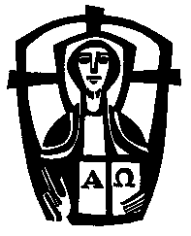 St Saviour’s, Abbots Langley & 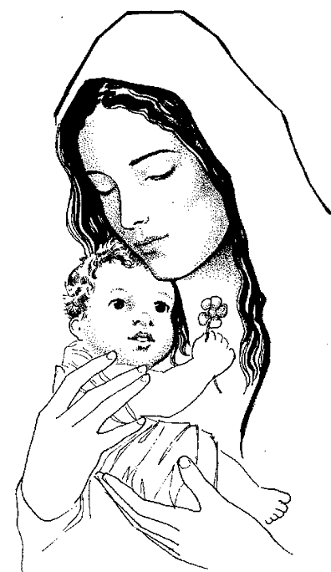
Our Lady Mother of the Saviour, Chipperfield
Served by the Society of the Divine Saviour – The Salvatorians
Parish Priest: Father Richard Mway, SDS
Assistant Priest: Fr Dieudonné Zeng, SDS
Parish Secretary: Katie Allam
The Priests House: The Presbytery, 96 The Crescent, Abbots Langley, WD5 0DS
St Saviour’s Church: 96 The Crescent, Abbots Langley, WD5 0DS
Our Lady Mother of the Saviour: Dunny Lane, Chipperfield, Kings Langley WD4 9DB
Tel: 01923266177 Email: abbotslangley@rcdow.org.uk
https://parish.rcdow.org.uk/abbotslangley/
Parish School: Divine Saviour Primary, Broomfield Rise, Abbots Langley
Executive Head Teacher: Mr Stephen Wheatley
Head of School: Mrs Helen Wilson
Tel: 01923 265607 www.divinesaviour.herts.sch.uk
Salvatorian Trustees Registered Charity No 231410/ Archdiocese of Westminster is a Registered Charity: 233699

Sunday 14th June 2020. Corpus Et Sanguis Christi: The Most Holy and Blood of Christ
This Sunday is Corpus Christi, the feast of the Body and Blood of Our Lord, that we receive at Mass, in the sacrament of the Eucharist. It is sad that we are not able to join our children at the church this weekend, which would clearly have been an appropriate day to celebrate their First Holy Communion with them. But we should use this day to remind ourselves of the importance of the Mass in our lives, and to look forward to the time when we can gather once again as a community for this sacrament. Meanwhile, we should surely be thankful that we shall soon be able to return to our churches for private prayers, and we hope that next Saturday the Church will be opened once all the safety measures are in place.

REOPENING THE CHURCH
We plan to re-open for private individual prayer at the following times, beginning Saturday 20 June 2020:
Tuesday 9.30am – 12noon
Friday 9.30am – 12non & 4pm – 5.30pm
Saturday 9.30am – 12noon
Sunday 10.45am - 2pm
These restricted hours are necessary to allow the Church to be cleaned more regularly and for our volunteers to head to and from here safely. The Clergy will continue to celebrate Mass in the Church outside these hours.

Please also note that:
* There will be a restricted number of people allowed into the Church and we ask that you only stay for up to half an hour per day to allow others the opportunity to enter.
* The toilets will be not be open to the public at this time.
* There will be no confessions being heard in the Church.
Following the government’s guidelines, the Church is open for private individual prayer only – any groups that gather
will be asked to separate and may be asked to leave.

Thank you for your co-operation.
A big thank to Parishioners who have responded to Fr Richard’s appeal to marshal and clean up the Church during the Coronavirus Pandemic. PPE will be provided for all the Volunteers. May God bless you all.
Some Words by Mother Teresa
If we really understand the Eucharist,
if we really centre our lives on Jesus’ Body and Blood,
if we nourish our lives with the Bread of the Eucharist,
it will be easy for us to see Christ in the hungry one next door,
the one lying in the gutter,
the alcoholic we shun,
our husband or wife,
or our restless child.
For in them, we will recognise
the distressing disguises of the poor:
Jesus in our midst.

SPIRITUAL COMMUNION Prayer of St Alphonsus
My Jesus, I believe that you are present
in the Holy Sacrament of the altar.
I love you above all things
and I passionately desire to receive you into my soul.
Since I cannot now receive you sacramentally,
come spiritually into my soul so that
I may unite myself wholly to you now and forever. Amen.

Food Collection: In response to the growing needs in the community during this lockdown period, we are asking all the parishioners to donate if they can.
All donations can be dropped to the Fathers house. If you ring the bell and leave your donation at the door it will be collected.
Food parcels/boxes will then be made and distributed; part will be sent to Watford Foodbank.
If you are aware of any family or individuals that you know may be struggling and would benefit from this please make the priests aware.
Thank you very much for your support and we pray for all to stay safe.
God bless!

We pray for the intentions offered at our Masses this Sunday: … We also pray for the sick at home and in hospitals, especially those affected by the Corona Virus, that God may heal them and strengthen their hope of eternal glory.

