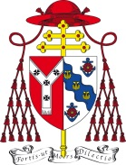

Pastoral Letter for the Twenty-seventh Sunday in Ordinary Time
2-3 October 2021

Dear Brothers and Sisters in Christ,

I am so pleased to be able to write to you now, at a time when our streets are again busier and, thank God, our churches are becoming fuller. I say again how grateful I am to all who have helped to keep our churches open and our parish communities functioning over these past difficult eighteen months: stewards, those who have kept in contact with the elderly and vulnerable, and so many others. I thank each and every one of you, most sincerely indeed.

The relationships we forge and sustain in our parishes make such an important contribution to the networks of contact, companionship, community through which we live. Indeed, the readings we have just heard speak of the variety of relationships which characterise our world.

The reading from the Book of Genesis speaks of our relationships with the animal world. Both this reading and the Gospel address marriage, a high point indeed of human contact and companionship. But also one that, as with all serious commitments, can be so demanding. Even as we do all we can to support matrimony and Christian families in our society, we must also ensure that those for whom it has ended in breakdown should always be offered our assistance and our prayers.

Today I would like to focus especially on the relationships we find in the community and companionship of the Church. The patterns and potential of parish life have been seriously and profoundly disrupted in the last eighteen months or so. So has life in our schools and in all other expressions of the life of the Church. But now that there is greater normality in daily life, we have a unique opportunity to refresh and maybe reshape these patterns of life in the Church.

Indeed, Pope Francis is asking us to do so. In starting what can be described as a ‘Church-wide listening process’ he is inviting us to listen again to each other, hearing experiences of faith with all its joys and disappointments, and to find new ways of strengthening each other.

Pope Francis envisages what is called a ‘Synodal process’. The language may sound a bit technical, but the word ‘synod’ means quite simply ‘journeying together’. The Holy Father is offering us the opportunity to participate in a time of listening and reflecting. He hopes this will help us to discern how God’s presence comes into our lives and what the Spirit of God is prompting us to do anew, so that we might be more alive and creative in our response to the call of Jesus, our Way, Truth and Life.

There is a world-wide aspect to this process, leading to a Synod of Bishops in 2023. But the Pope asks us to begin in our own situations, with our own experience, especially of this last year and a half which has surfaced both strengths and weaknesses in our life as the Church. The kind of questions we can explore are these: during this terrible pandemic what strengths did I find in my faith and faith community? How, during this time, was I disappointed and sorrowful? In what ways did the grace of God most clearly touch and uplift me? Whom did we neglect the most? Who feels left out? What could we do better? How do we choose priorities for our own mission?

I have found these words, taken from the guide to this process issued by Rome, to be helpful and inspiring:

‘The purpose of the synod is not to produce more documents. Rather it is intended to inspire people to dream about the church we are called to be, to make hopes flourish, to stimulate trust, to bind up wounds, to weave new and deeper relationships, to learn from one another, to build bridges, to enlighten minds, warm hearts and restore strength to our hands for our common mission.’ (Vademecum 1.3)

In our diocese, as in every diocese throughout the world, this ‘Synodal’ pathway will begin on the weekend of 16/17 October. Our immediate part in the process is short and concentrated: as a diocese we have to have our reflections brought together by February. So in the next few days and weeks there will be invitations issued for a variety of ways in which you could take part, in your parish, through the school. Joining in will focus not so much on discussing ideas but in sharing experience and, on that basis, trying to sense what needs to be done, all shaped by prayer and under the guidance of the Holy Spirit.

We all know the adage ‘It’s good to talk’. We know how important communication is for every relationship. But talking must be matched by listening. Indeed, often the listening is more demanding, and really it should come first. So it is with this ‘Synodal’ invitation. The pathway is listening, the task is discerning together the important lessons and prompting of the Holy Spirit, and the outcome greater participation in the life and mission given to us by the Lord.

This lovely initiative of Pope Francis is an opportunity for us to show our care for the family of the Church. It shines with the Holy Father’s character of openness, compassion, and eagerness for renewal. Please do take it up in whatever ways you can.

May God bless our efforts, open our hearts to one another and prompt us powerfully to know more clearly the way God has set out for us to be messengers of the joy and consolation which God alone can provide.

May God bless you all,
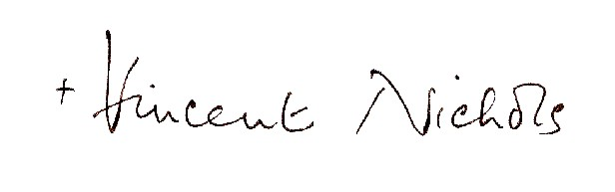
Cardinal Vincent Nichols
Archbishop of Westminster

