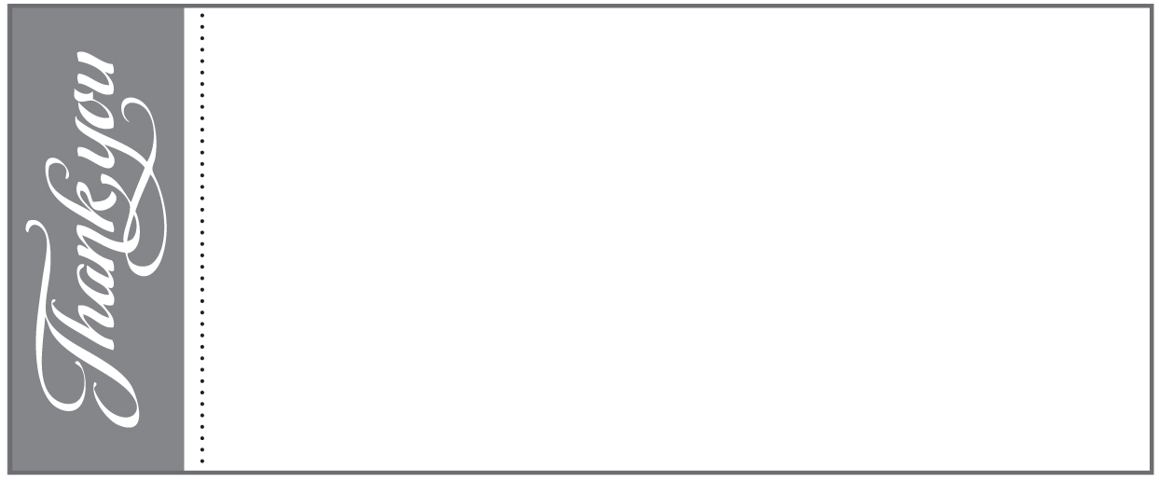

Collections 27/28 August 2016

*St Josephs and the English Martyrs:*

Collection: £1373.02 Standing Orders: £1358

*Holy Cross:*

Collection: £95.17 Standing Orders: £195

*Most Holy Redeemer:*

Collection: £115.96 Standing Orders: £82

Hail, holy Queen, mother of mercy; hail, our life, our sweetness, and our hope! To you do we cry, poor banished children of Eve; to you do we send up our sighs, mourning and weeping in this vale of tears. Turn then, most gracious advocate, your eyes of mercy towards us; and after this our exile, show unto us the blessed fruit of your womb, Jesus. O clement, O loving, O sweet Virgin Mary.

Parish Administrator – Debbie Jackson

Parish Office: 01279 654063 (10am-3pm)

Parish Centre Bookings: [bishopsstortford@rcdow.org.uk](mailto:bishopsstortford@rcdow.org.uk)

Child Protection: Keith Irvine safeguardstjoes@virginmedia.com

SVP (St Joseph’s): 0750 409 9571

Baptism: Forms and information are available from the Parish Office.

Marriage: enquiries call the Parish Office or email

First Reconciliation & First Holy Communion

Forms available from 10 July 2016 to be submitted

By 5th September 2016

Confirmation**:**  now closed for 2016

***Fr Peter writes:***

Work on our new **Accessible Toilets** began on Aug 1st and will finish on Nov 1st! During this time there will be NO TOILETS available at the Church. Toilets will be available during Mass times in the Parish Centre – so PLEASE make sure you “Go before you come”!!

In the next couple of months we expect the **High Altar** and its Baldachino (Canopy) to be cleaned and, possibly, the marble walls of the Sanctuary.

***Thank you to all our donors***

**Sacrament of Reconciliation and First Holy Communion**

**St Joseph and the English Martyrs 2017**



Application forms and sign-up sheets have been available from the Sacristy after every Mass since Sunday 10th July 2016 for Children who wish to receive the Sacrament of Reconciliation and First Holy Communion and will be at least 8 years old on or before 31 August 2017. All forms must be signed for by the parent of each child – please do not take a form for someone else

**Forms must be returned to 3 Windhill**

**by Monday 5th September 2016**

***Fr Peter will not allow any exceptions to this cut off date***

**WELCOME BACK** –to Father Fortunato who is back from his summer holiday and to all of our Parishioners. We hope that you have had a relaxing break. **BON VOYAGE** to Father Peter who will be away this month. We also express our sincere gratitude to Father Angel and the other priests who celebrated Mass with us during August. Fr Angel has now returned home to Spain. We hope that he will visit us again sometime soon!

**CARITAS WESTMINSTER TRIP TO THE “CALAIS JUNGLE” - On Thursday the 22nd of September, Caritas Westminster will be sending a team of staff and volunteers to visit the Jungle in Calais. The team will be working with Brother Johannes Maertens who founded the Mother Maria Skobtsova House of Hospitality based in Calais.**

**Please help by donating food clothes and toiletries *(see list in the Information Area at the back of the Church)* to St Joseph’s Pastoral Centre, St Joseph's Grove, The Burrough's, Hendon, London NW4 4TY Or call: 0207 931 6077**

**GIFT AID CLAIM APPROVED** - Good news, our 2015-16 Gift Aid claim for St Joseph’s has been approved, for £25,669.13. We have also received £23,000 from our Growing in Faith Campaign to which so many of you were very generous – 20% of all donations comes back to us to help pay for our new accessible toilets. Thank you.

**ST MARY’S MOTOR SHOW – Sunday 11th September 2016 11am – 4pm** A Great family day out with attractions, rides and stalls. Visit the dealership’s latest models and exhibitors’ cars. This year ‘ The Batmobile’will be present**! Visit** [**www.stmarysmotorshow.co.uk**](http://www.stmarysmotorshow.co.uk)

**BEGINNERS GUIDE TO IGNATIAN SPIRITUALITY**

**DEANERY PILGRIMAGE TO FATIMA** (**22nd to** **26th May 2017)** a 4-night pilgrimage to the shrine of Our Lady in Portugal, 100yrs on from the apparitions.  The price is expected to be £575.  If you are interested, please contact St Augustine’s church on 01992.440986 as soon as possible to register your interest

**SVP COFFEE MORNING** Tuesday 6th September, 10am to 11.30 am in the Parish Centre. Come along for some coffee and cake and catch up with friends you’ve missed during the summer - all most welcome. For a lift phone Jill on 657575 or Astrid on 465200

**FOOD BANK COLLECTION** (St. Joseph’s): Thank you to all who contributed during August. The collection has finished for now but we expect to start up again later in the year, so do keep an eye open for details

**PARISH MAGAZINE** Deadline for the next issue is Friday 23rd September. Copy will be most welcome; please e-mail items for inclusion to [astriddavies@hotmail.co.uk](mailto:astriddavies@hotmail.co.uk) or leave with Debbie in the Parish Office.

**ENCOUNTER PROGRAMME 2016-2017** now available at back of church with the newspapers. All welcome to attend for one or more meetings. Enquiries: B/S 652060 or 659371

**AID TO THE CHURCH IN NEED** the Penny Collection has a target of £1,000. Do please continue to put your spare change in the designated jar at the back of the church at St Josephs weekend Masses. Your support is greatly appreciated

**CONGRATULATIONS** to Father Peter and Father Fortunato this month as they celebrate respectively their 4th and 1st anniversary in our Parish – we are blessed and thankful to have you both here with us.

 **HOLY TRINITY WINTER NIGHT SHELTER VOLUNTEERS** are needed to help feed, welcome, befriend, protect and support those who need to access the hall between December and March. If you feel that you would like to help please contact 01279 507464 or email: [megan.lowe@salvationarmy.org.uk](mailto:megan.lowe@salvationarmy.org.uk)

**RCIA 2016/17**

Have you missed out on some of the Sacraments? Are you interested in learning more about the Catholic Faith? Would you like to join the Catholic Church? Is there someone you know who would be interested in becoming a Catholic, perhaps your husband or wife, girlfriend, boyfriend or neighbour? COME and JOIN the Journey of Faith at St Joseph’s, Bishop’s Stortford which starts on **Monday 12th September**. Please contact Fr Fortunato at [bishopsstortford@rcdow.org.uk](mailto:bishopsstortford@rcdow.org.uk) to pre-register or call 01279 654063

**ALTAR SERVERS TRAINING SESSION 2 –** There will be the second session of Altar Servers training on Saturday 24th September 2016 with Father Fortunato. Training at Most Holy Redeemer will commence at 10.30am and Holy Cross at 12 noon

**CERTIFICATE OF CATHOLIC PRACTICE -** Applicants for St Mary's School 2017 will need to obtain a Certificate of Catholic Practice. A’ lilac coloured’ application form for a certificate can be collected from No 3 Windhill or the Parish Office, in person. Once completed it should then be posted through the letter box of No 3 Windhill marked for Fr Peter's attention **with a stamped addressed envelope please.** Part of the application requires you to make a declaration about how often you come to Mass. For the purposes of this form your family is expected to attend Mass weekly, although of course you may be away for holidays etc. If you regularly attend Mass at an ethnic chaplaincy, then you should take the form there, not to Fr Peter. If you do not generally attend weekly, then Fr Peter cannot state that you are a practising Catholic. Since the form is part of the legal admissions process he cannot tell lies on it. All applications will be processed after 1st October when Fr Peter returns from his break and certificates, if granted, posted to you, so that you can send in with your completed application to the school by their deadline of 31 October 2016

**CAFOD SUPPORTERS MORNING - Saturday 17th Sept 10am-12, Oakwood, North London.**CAFOD will be hosting a supporter’s information morning with a guest speaker who has first- hand knowledge of our work in Bolivia. Bolivia is the country we are focusing on this Harvest Fast Day.

Come and hear how CAFOD is helping communities, thanks to your support. Meeting will take place at 10am at CAFOD Westminster Volunteer Centre, 1st floor, Catholic Church of Christ the King, 29 Bramley Road, London N14 4HE.Bookings taken on 0208 449 6970 [westminster@cafod.org.uk](mailto:westminster@cafod.org.uk)

Sunday 4th September 2016 – 23rd Sunday in Ordinary Time

*St Joseph and the English Martyrs:* 9am Mass John & Fran Billington Special Intention

11am Mass Thanksgiving – Doreen & Michael Frost

12.30 Baptism – Victoria Kapel Mensah

6pm Mass Larry Andrews RIP

*Most Holy Redeemer (Sayesbury Road, Sawbridgeworth):* 9.00am Mass – Bridie Lynch RIP *Holy Cross (at St Andrew’s, Church Lane, Much Hadham)*:

11.15am Mass – People of the Parish

Monday 5th September –feria

9.15am Morning Prayer  
 9.30am Mass – Matt Fay RIP

Tuesday 6th September – feria

**NO 6.30am MASS**

9.30am Mass – Marjorie Jessop RIP

Wednesday 7th September –feria  
 **NO MASS**

Thursday 8th September- The Nativity of the Blessed Virgin Mary

*St Joseph and the English Martyrs:*   
9.30am Mass – Private Intentions

*Most Holy Redeemer*

**NO 12.30 MASS**

Friday 9th September – St Peter Claver, Priest

*St Joseph and the English Martyrs:*

9.15am Morning Prayer  
 9.30am Mass – Mr and Mrs Lindeman Thanksgiving

Saturday 10th September –Blessed Virgin Mary on Saturday

*St Joseph and the English Martyrs:*

5.15- 5.45pm Adoration of the Blessed Sacrament &

Sacrament of Reconciliation

6pm Mass People of the Parish

✠

*Mass requests*

*Please fill in the envelope provided, the date & time you would like the Mass with a contact number/ E-mail address and hand in to the Sacristy, Parish Office or 3 Windhill.*

*Thank you very much.*