My Polish Friends by Clare Hodgson – May 2017 Edition
Doreen Brown’s article ‘Best Friends were once Strangers’ brought back many happy memories of what was a wonderful period at St. Mary’s. I was fortunate to be in the sixth form in 1990-92 and got to know Ania, Hanna and Krzysztof particularly well. As Doreen mentioned, the group were extremely capable students whose work ethic was an inspiration, particularly as they did not have parental input or the extremes of ‘helicopter parenting’ we are sometimes guilty of in these times of data driven education. This dedication was also inherent in their approach to the arts and it was through music that I became particularly good friends with Krzys. I will never forget the Head of Music at the time, Peter Baker, managing to wheel the classroom upright piano out of the music department, over bumps. up a hill, through the grass and into the hall so that Krzys and I could perform the Carnival of the Animals on double pianos. This was supported by a small orchestra and remains one of the highlights of my time there.
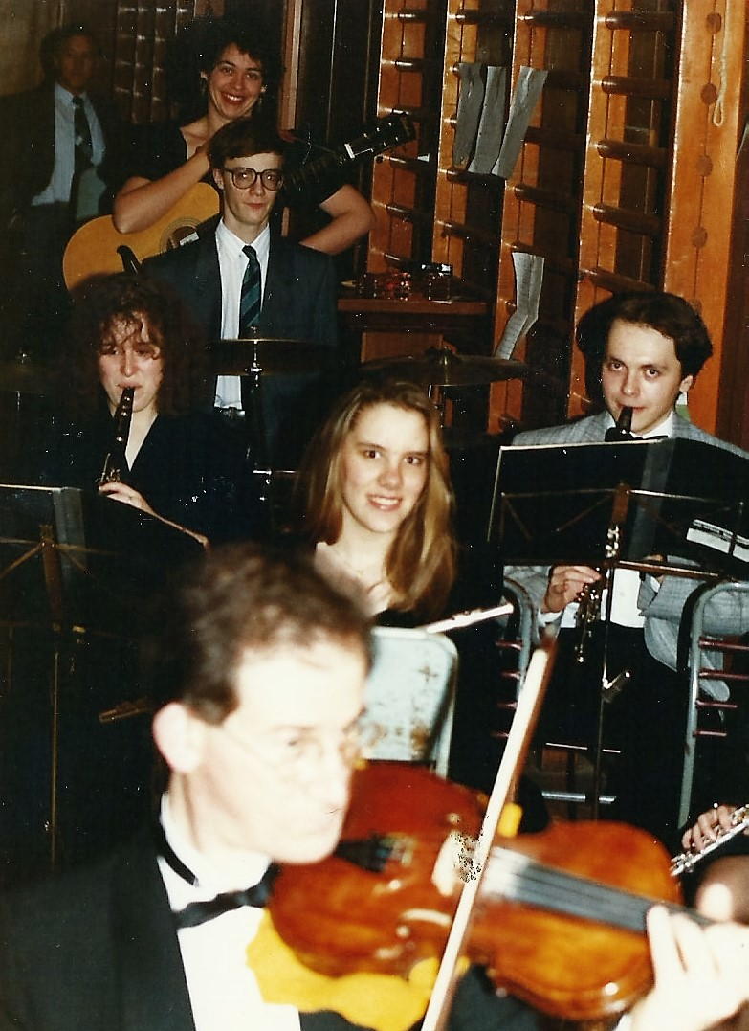
The students also got involved in the parish musicals, Krzys played clarinet for ‘The Wizard of Oz’, I will always associate him with the repeated squeaky dissonance of the ‘fill music’ awaiting the entrance of the Wicked Witch, one Astrid Davies, whilst an enthusiastic Dave Morson, director, had the set decorated with plastic bats! It was the Polish contingent who braved my free student tickets to the Harlow Chorus performance of ‘Arnell – War God II’ an ambitious electro-acoustic choral work accompanied by orchestra and electronic sound track. I thought it was fantastic but it was not a box office success and the Polish students were the obvious and enthusiastic attendees. This was reflective of their supportive and open outlook to new experiences. We also shared a great Polish night at the Wojcik’s singing Polish songs (listening in my case!), jokes and food.
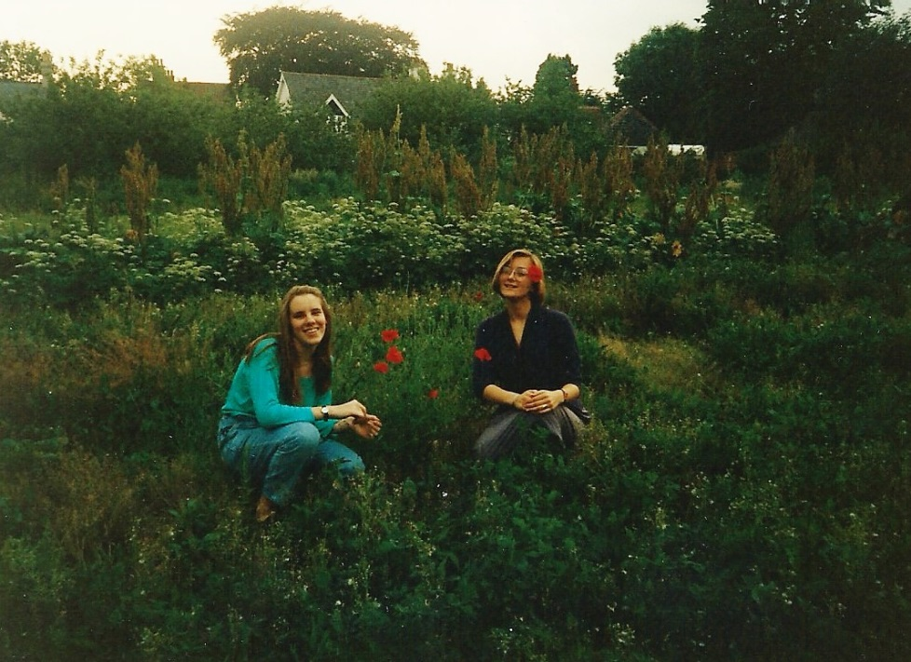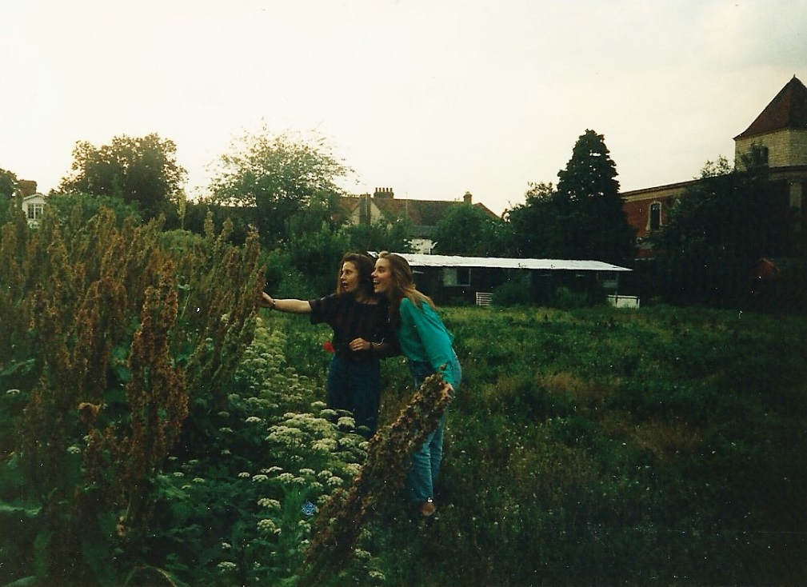
My continuing friendships with the group resulted in a visit to Poland in the summer of 1992. It was incredibly exciting flying off to Warsaw to meet my new friends. Poland was undergoing immense changes at the time and it was a real privilege to explore this beautiful country with such generous companions. We travelled Warsaw, the lakes and finally Gdansk. For me, it was the completion of a longer journey, my own grandfather, Tadeusz Glowick, was Polish and had to leave Poland during the war. I knew nothing of my Polish family or connections although my parents, Peter and Sarah Kinsella, subsequently tracked down Mum’s relations. However, there was a feeling that we had come full circle, Grandad had left Poland during a time of war, I had returned to Poland with students who had come to meet me through another war. I shall never forget that wonderful period of discovery, debate, culture, laughter and most importantly musical sharing. What wonderful opportunities and friendships came for us at St. Mary’s and in the wider parish. I would like to thank those students and their families for all we learnt and for the great friendships we shared.
I would also like to thank the ambitious staff, parishioners and priests who took this project on. I am not sure it is something that could have happened today but I am so grateful it did!

