Trees in our Grounds 3 by Margaret Morgan
The Mulberry Tree.
Our mulberry tree was the last tree in the grounds to display its leaves and now already it is showing the fruits which are to come, a wonderful promise. It is a pleasure to walk under it spreading boughs on the way from the car park to Cardinal’s Walk.
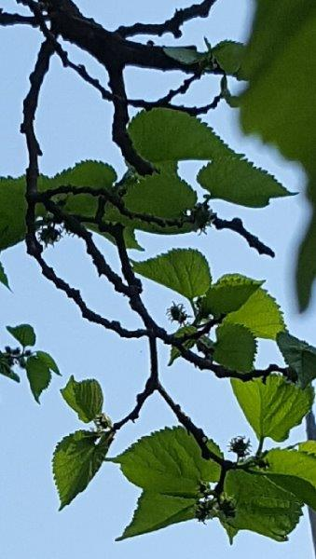
But on 28th May the Independent Online Newspaper published the photo of another mulberry tree and tells a chilling story in an article taken from the New York Times. The mulberry tree stands in a corner of the campus of a religious teaching college in Togh Bairdi, Northern Afghanistan and shades the grave of Malawi Sha Agha Hanafi who founded the college around two decades ago. He died a victim of the Taliban as a result of speaking what he saw to be the truth, that the ongoing war they are waging is not a legitimate Holy War. This revered teacher, a member of the ulema, the well-known scholars, posed a threat to the Taliban to whom the legitimacy of their war is of huge importance. So he was killed by a bomb. He was one of a growing number of very well- versed men to lose their lives in this way. After much serious study he had decided the war only carried on because of a search for power.
When we walk under our tree we could pray for honest men of every faith who have no freedom of religious expression. We could pray for the determination to study our own scriptures openly and honestly so that they shed a living light on our ever-changing world.

