Trees in our grounds by Margaret Morgan – a featured article in our 2017 Lent edition of the Parish magazine. All photographs courtesy of Margaret Morgan
‘Out of the ground the Lord God made to grow every tree that is pleasant to the sight and good for food’ Genesis 2:9
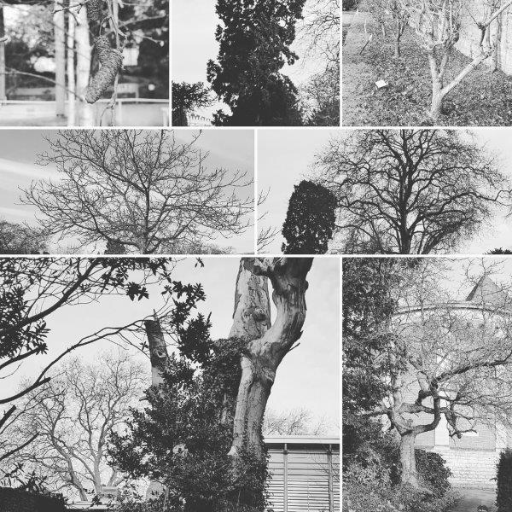
We are fortunate here in St. Joseph’s church. Whether we come to Mass by car or on foot we are almost sure to be aware of beautiful trees, some new but some very old. Beneath them pigeons strut and squirrels romp; hidden robins sing and blackbirds dig around for live food. In the yew trees sometimes a thrush is enjoying the berries. At the moment the deciduous trees are showing their spectacular profiles in bare branches but already buds are beginning to green and swell. Long may they be assured a sustainable habitat!
(Arbutus unedo) Serves as a bee plant for honey production and fruits for birds, and some say that raki can be brewed from it! The tree matures in autumn and winter when pollen and food are beginning to get scarce. Much diminished in size it still grows against the wall, opposite the door of the Old Monastery. Both its spherical cream and orange fruit and its clusters of white bell-like flowers are a beautiful sight. An unvandalised specimen grows inside the main gate of the town cemetery on the right of the path.
The Mulberry.
(Morus nigra)
The mulberry has been known in England since Tudor times when James the First thought to start a silk industry. Unfortunately he had been sold a black mulberry while silk worms only ate the white variety which has a much milder taste. Its gnarled and twisted limbs make it an interesting tree. You will not find the fruits in shops but it’s worth trying out. Birds love them, ripe or unripe.
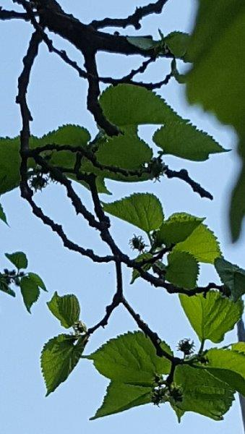
Apples and Pears
(Malus pumila) plus many varieties of the Pyrus species
Grown for thousands of years in many varieties including ornamental trees with beautiful blossom and richly coloured fruit, such as once grew at the corner of WCC and is no more. These are well-known to us and give us visual pleasure in the Spring and beautiful fruit in Autumn. Birds love the small grubs which can spoil the fruit. The codlin moth caterpillar is one example
Plane
(Platanus)
A drought- tolerant tree native to the northern hemisphere, it is a tree popular in cities. It seems to have another advantage in that it resists pollution and seldom falls sick. There is little wild life connected with it but it is an impressive and decorative tree with handsome, leathery leaves and spherical flowers. Mice and squirrels may eat the fruits
Monkey puzzle tree
(Araucaria araucana or Chilean pine.)
This family of fire-proof trees has been around, often standing up to volcanic eruptions and forest fire, since dinosaurs roamed the earth and came to be a favourite curiosity in Victorian parklands. No monkey has been known to solve the puzzle or to be associated with the tree in any way. British wildlife has little to do with it.
Copper Beech
(Fagus sylvatica purpurea)
This tree can be a home for at least three leaf-eating caterpillars of moth varieties. The seed is eaten by mice, voles and squirrels. The caterpillars are eaten by birds. The beech has often a long life. There are remains of two old trees at the back of WCC. Their dead and dying wood can be home to fungi, insects and lichen and other creatures such as birds that nest in holes drilled in dead wood and to parasitic plants such as ivy whose juicy black berries delight pigeons and blackbirds.
Silver birch
(Betula pendula)
This tree is an addition to any garden. It is near the top of the list for being insect-friendly, therefore popular with birds. Its interesting rough and scaly bark provides all sorts of habitats. Its penetrating roots and plentiful rotting leaves bring up nutrients from deep down and return the nourishment to the soil, gradually enriching it. This is particularly important in establishing a growing environment for other vegetation.
They are graceful and lovely trees.
Walnut
(Juglans regia)
These trees provide food for us and for mice and voles that in turn are part of the food pyramid for owls. Their leaves are home to micro moths whose caterpillars support birds.
All signs of biodiversity are precious in these days of mass food production and monoculture. So let us celebrate Our Common Home and be increasingly aware of it, and its labour-saving and money-saving potential. Imagine if we had to do all that pest control, rubbish eating, bacterial breaking down, and pollinating completely alone without nature’s FREE input! LAUDATO SI!
Trees in our grounds; catkins, blossom and pollination.
Laudato si’
‘When we speak of “environment” what we really mean is a relationship existing between nature and the society which lives in it. Nature cannot be regarded as something separate from ourselves or as a mere setting in which we live. We are part of nature and thus in constant interaction with it’ Pope Francis. Laudato si’. 139
We who have gardens and wild patches of land are important to the survival of the honey bee. Honey bees are not the only pollinators; flies in various sizes, moths, hover flies and wild bees of all sorts can do the job. Many are visible in the apple and pear trees around the car park at St. Joseph’s. They are also visiting the wild flowers that were growing round its grass margins, violets, primroses, small geums, lesser celandine, ground ivy, white dead nettle and honesty to name but a few until they were recently reduced to a black mush by a cutting machine.
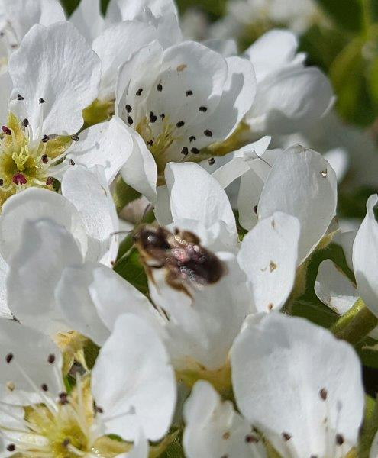
The beauty of the honey bee as pollinator is that it lives in large colonies and a colony can visit thousands of blossoms in a day, working towards a good crop of apples, pears, cherries for us and much good nectar for themselves. Monoculture and a kind of scorched earth policy at the edge of fields have impaired the bee’s ability to search out fields and tell each other where it is. Why bother if there is field after field of rape seed in blossom? In America huge almond groves have had the same effect, but when biodiversity is neglected blossom seasons are quick to end. Bees can find themselves marooned a silly distance from new supplies. Many are trucked across America in huge numbers. Up to 30% die or succumb to stress, diseases and concentrated pesticides. In our own back yards we can do better than that.
Have a look at what’s buzzing around, live and let live. We need all the species we can get.
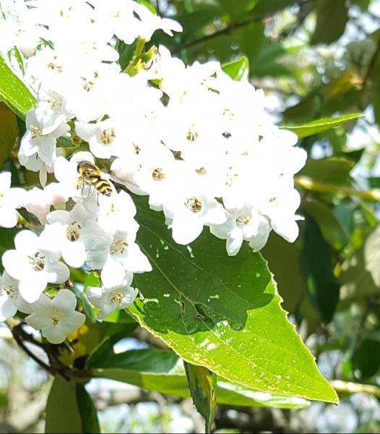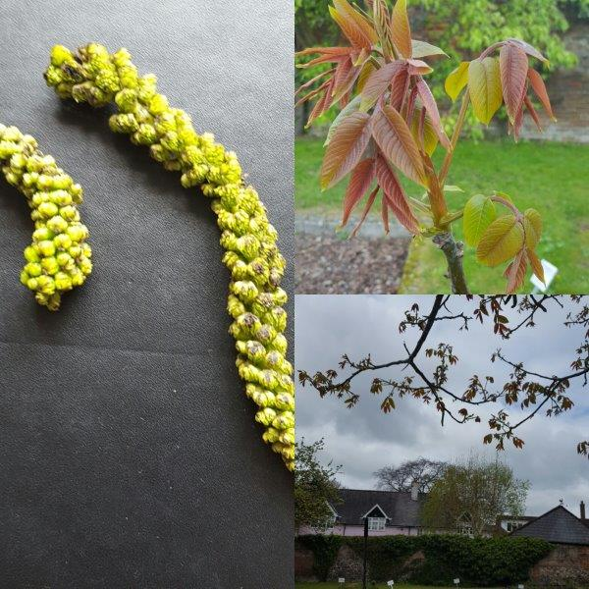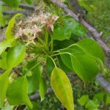
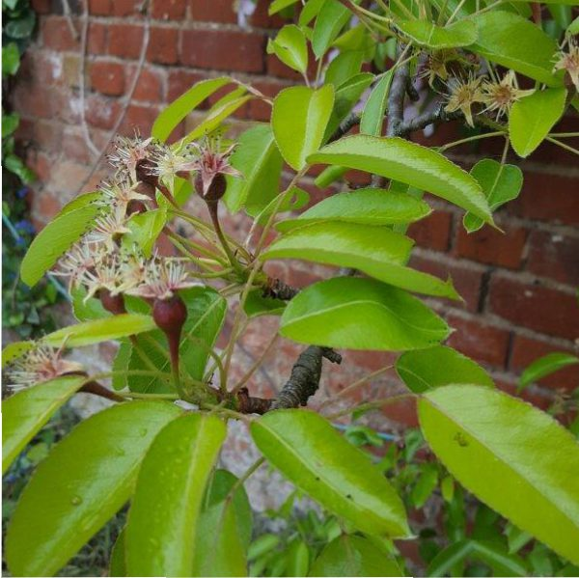
There are pests, notably the codlin moth as it lays its eggs in blossom so the caterpillars get into our apples and eat their way out later in the season
The codlin moth has enemies, certain beetles whose preferred home is stinging nettles. So we mustn’t be too quick to poison the nettles. Tortoiseshell butterflies will thank us for leaving the nettles to them. If lacewings find a decent winter hotel they will emerge and polish off the aphids. Ladybirds will help them. Blue tits and great tits are scouring trees and bushes for tiny grubs.
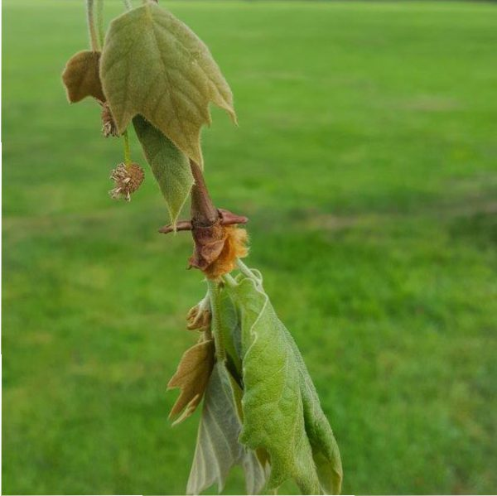
Starting with two predators: the zebra spider. It jumps to catch smaller insects like aphids. Then there is a wolf spider. It’s front legs are sticking out as it lurks under its nursery web.
The bumble bee and the hover fly are both pollinators. The hover fly does predation as well. The red admiral is a pollinators. I watched this one being aggressive to a comma butterfly, aerial combat. I hope to get an ant and a beetle but insects are not that helpful at sitting still!
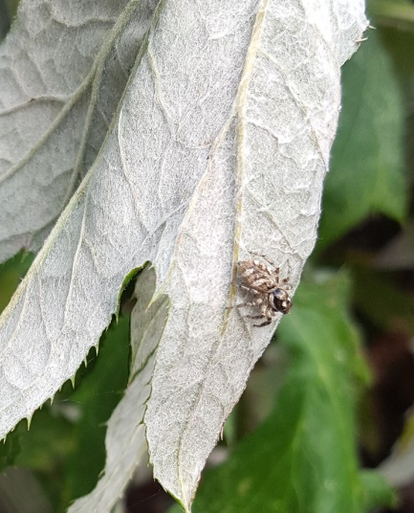
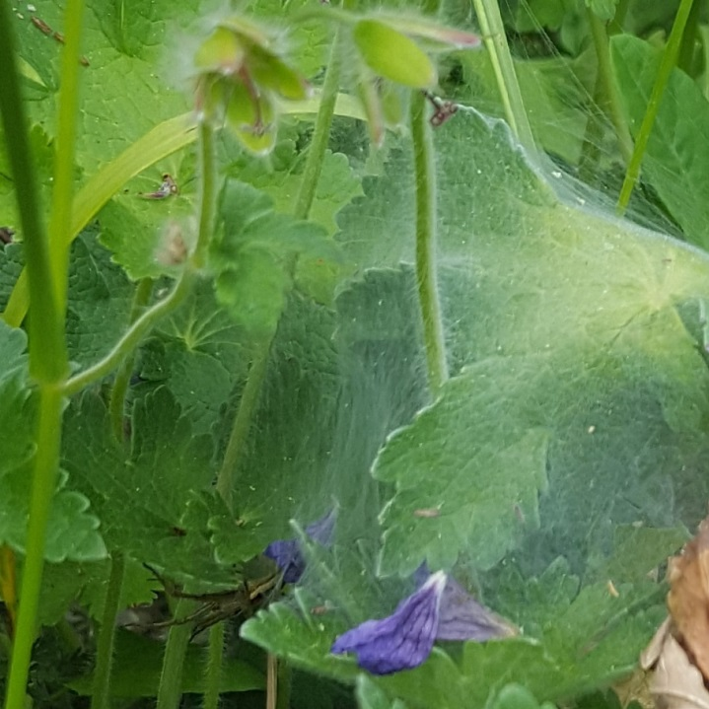
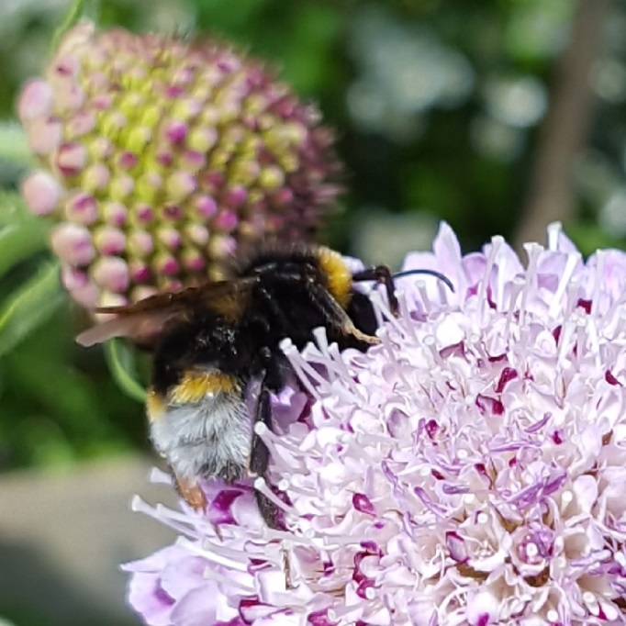
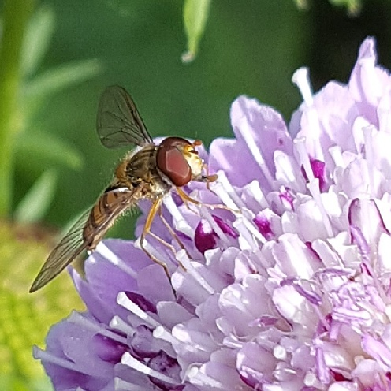
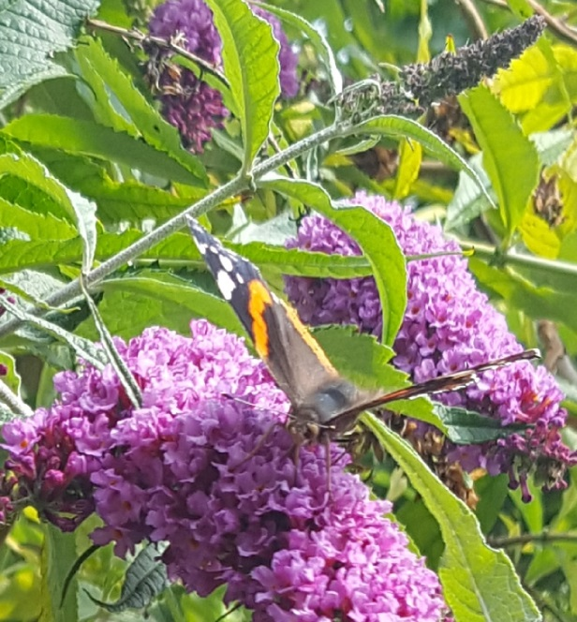
Some of the trees in St. Joseph’s are independent of pollinators and grow both male and female flowers. Pollination is then helped by wind, sometimes even by gentle dispersion in dew or rain. There are six walnut trees in the cark park. The two furthest from the entrance are putting out leaves and spattering the ground with green, substantial caterpillars up to three inches long. The silver birches, copper beech and plane tree are similarly wind-pollinated.

We have to remember, as Pope Frances say, it’s all joined up and we are an integral part of all this bountiful planning. Laudato si

