Station 1: Jesus is sentenced to death
Colour the picture of Jesus with Pontius Pilate
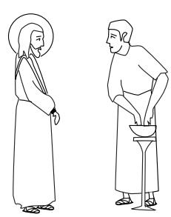
Station 2: Jesus takes up his cross
Do you know someone who is carrying a burden? Trace this cross and write their name on it.

Station 3: Jesus meets his mother
Think about people you love. Are there people who you find it hard to love? Write their initials here and pray that Jesus would help you to love them just like he loves them.

Station 4: Jesus falls
Colour this picture of Jesus as he falls for the first time
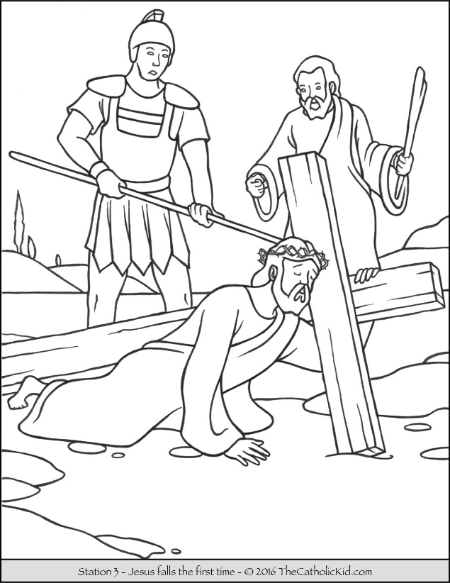

Station 5: Simon helps Jesus
Draw yourself helping Jesus carry his cross.
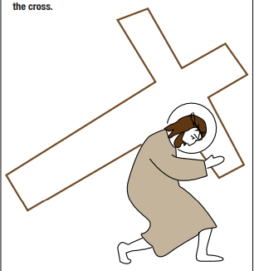

Station 6: Jesus meets the women and children
The women were crying as Jesus walked past but he told them not to cry for him, but for themselves. What sins do you need Jesus to forgive? What are you sorry for?

Station 7: Jesus dies on the cross
Is there anyone you need to forgive? Write their name on the cross below.
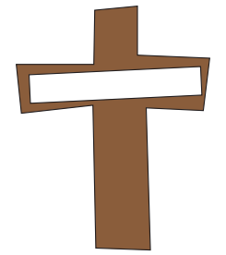

Station 8: Jesus is taken down from the cross
How do you think Mary would have been feeling as she held her son? Write down what you might say to her.

