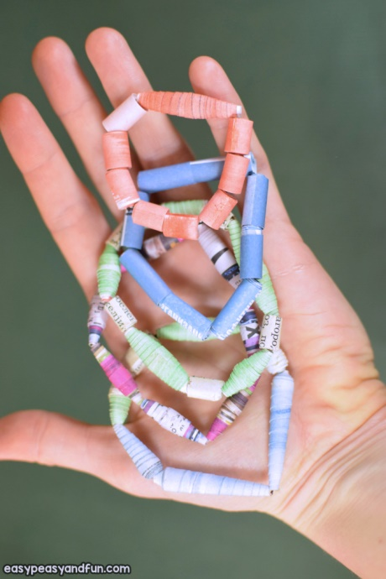**How to Make Paper Beads Bracelet - Activity Week 12**

**What you need:**

**Newspaper/ magazine pages/ book pages/ coloured paper**

**scissors pencil ruler glue stretch yarn toothpick**

* 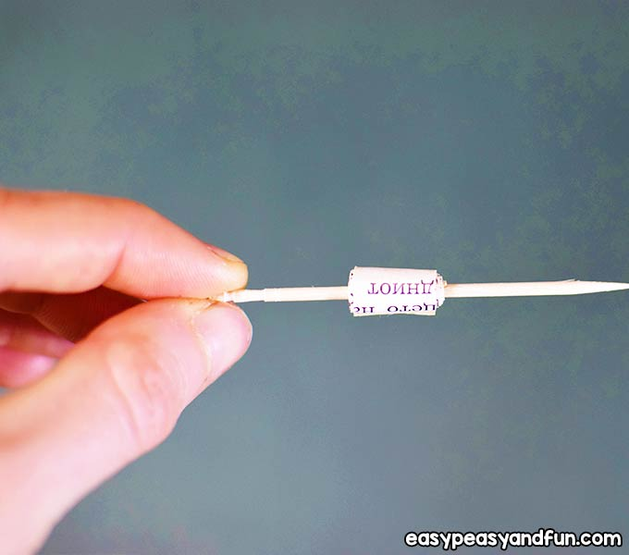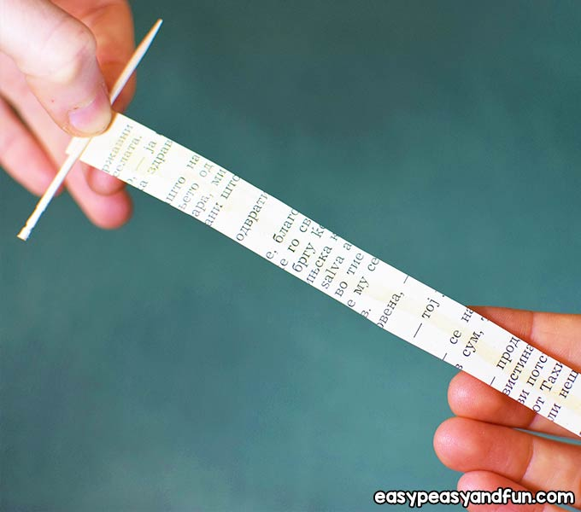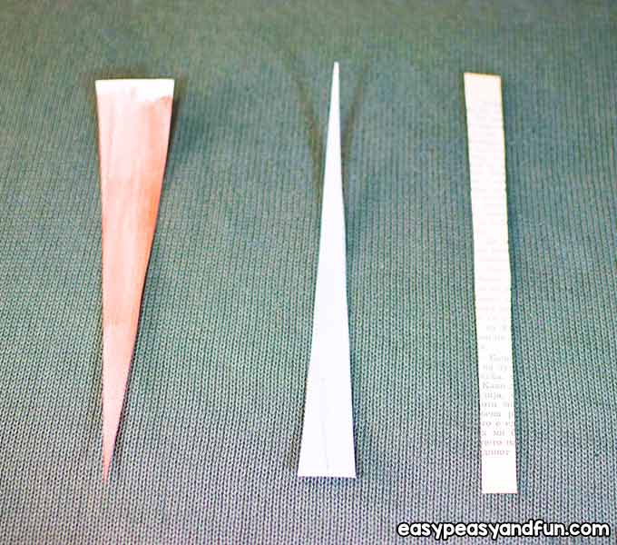

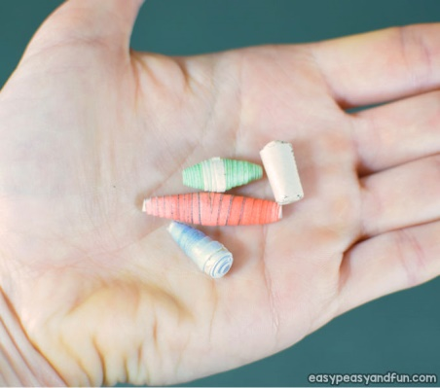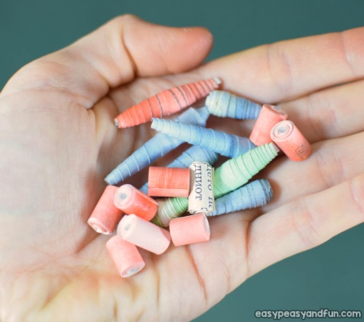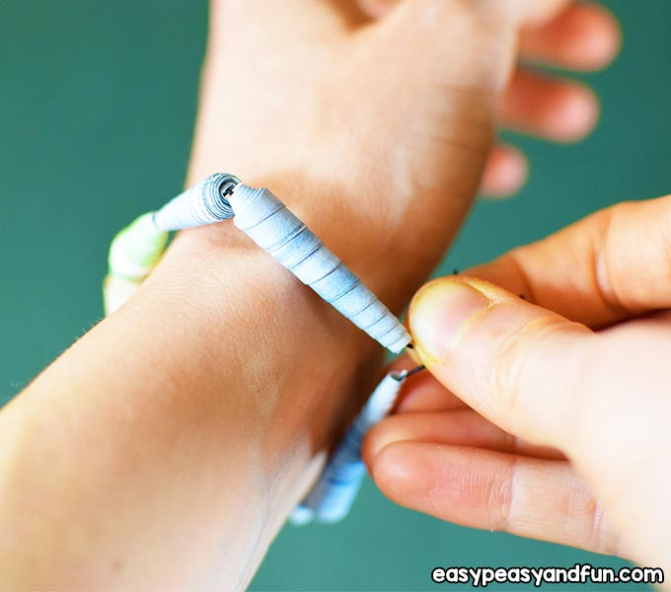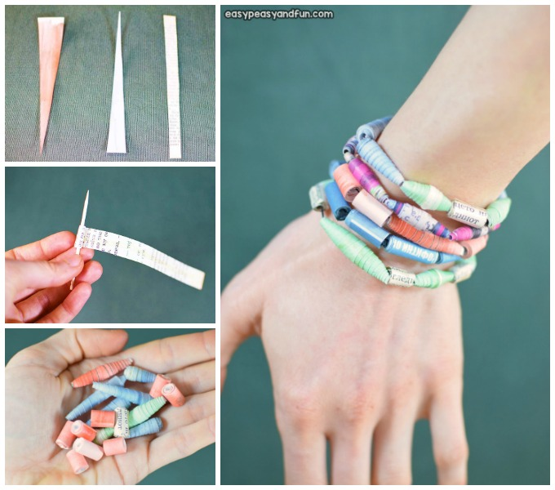

**Repeat using different shaped and coloured strips.**

**Measure correct amount of stretch yarn, thread beads and tie off.**

**Apply glue to the outside of bead and allow to dry.**

**When tightly rolled on itself and when finished remove to dry.**

**Spread glue along one side of paper and start to roll around toothpick**

**Cut stripes of paper at least 8 inches/20cm long.**

**Instructions and images obtained from**

**easypeasyand fun.com**