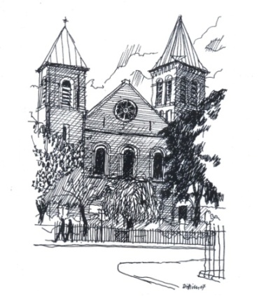

St John the Evangelist Catholic Church

39 Duncan Terrace
Islington
London N1 8AL

Tel. (020) 7226 3277

Confirmation Course 2022
Parishes of St John the Evangelist and Blessed Sacrament

Dear Candidates and Parents,

After the turmoil of the Covid-19 situation last year we are delighted to announce that this year’s Confirmation Course will start on Monday 24th January 2022! We have a great team of committed catechists who will be helping run the programme this year and we are looking forward to welcoming all the candidates, especially the ones who could not be confirmed last year!

Requirements:
- Candidates should be in Year 9 or above
- Registration Form, which needs to be filled out and returned to your parish by Friday 14th January 2022
- Photocopy of the candidate’s baptism certificate
- Donation of £30 to cover the costs of the materials and the retreat.
If you have any difficulty with this, please speak to Fr. Jakub or Sr. Miriam

Please note: The first meeting with the candidates and parents or caregivers will take place on Monday 24th January 2022 at 7 p.m. at St John the Evangelist Church, Duncan Terrace in the Crypt of the Church.

St John the Evangelist Catholic Church
39 Duncan Terrace, London N1 8AL
Tel. (020) 7226 3277

CONFIRMATION REGISTRATION FORM 2022

Dear candidate this form should be completed personally by you with the help of your parents if necessary. Since you are willing to undertake this journey of maturing in your faith, we remind you that you are expected to attend Sunday Mass regularly throughout the whole period of preparation for Confirmation.

Name of Candidate___________________________________________________

Date of Birth____________________________I am now aged________________

Address_____________________________________________________________________________________________________________________________________________________________________________________________________

Home Tel__________________________Mobile___________________________

Email______________________________________________________________

School__________________________________________________________________________________________________________________________________

Parish______________________________________________________________

Date and Place of Baptism_____________________________________________

Please supply a Copy of your Baptism Certificate.

Please complete this form and return it to your respective Church (St John the Evangelist or Blessed Sacrament) by Friday 14th January 2022.

Protecting your privacy
Your personal details are required for the specific purpose of processing your Confirmation registration form. This information will be held on file/stored securely on the St John the Evangelist Catholic Church computer for the duration of the programme.

