November 2021
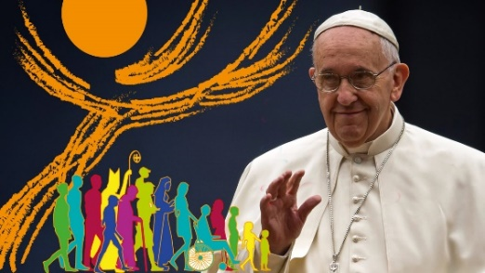
SYNODAL PATHWAY
Pope Francis has invited the worldwide Church to a time of listening – of listening deeply to each other as we walk side by side, telling our stories of faith.

SYNOD – a late Middle English word, via late Latin, from the Greek word ‘sunodos’ (sun = together / hodos = way)

Every voice matters on this journey, and the Church wants to hear from you. These questions are designed to help you reflect a little on your own experience of faith, particularly during the pandemic, and to share individually your hopes and dreams for the future.

You are invited to answer the following questions. Feel free to expand your answers on to the back of the page if necessary. What you write will contribute to our feedback to the Diocesan Synodal Team. Thank you for your generosity in responding in this way.

1 What do you value about our Church community?

2 What is your hope/wish for the Church, so that it can become more outward-looking and of
service to the community?

3 If we are to achieve your hope(s) / wish(es):

(a) What could we stop doing?

(b) What could we do differently?

(c) What could we introduce or develop?

When completed please return this questionnaire to the Parish Office, or to the person who handed it to you. Thank you.

More Information available from The Bishops’ Conference of England & Wales - https://www.cbcew.org.uk/

