Thursday 24 December Christmas Eve
11-12:00 CONFESSIONS
16:00 VIGIL MASS OF CHRISTMAS, especially for young children.
18:00 VIGIL MASS OF CHRISTMAS
21:00 MIDNIGHT MASS OF CHRISTMAS
The Mass will begin with the Blessing of the Crib and Christmas Proclamation.
Friday 25 December Christmas Day – NATIVITY OF THE LORD
09:00 Mass
10:30 Mass
12:00 Mass
There is no evening Mass
Saturday 26 December ST STEPHEN, The First Martyr 10:00 Mass
Sunday 27 December St John, Apostle & Evangelist
09:00 Mass
11:00 Mass
18:30 Mass

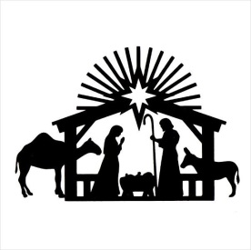
Monday 28 December THE HOLY INNOCENTS, MARTYRS 10:00 Vigil Mass
Tuesday 29 December The Holy Family of Jesus, Mary & Joseph 10:00 Mass

Wednesday 30 December Sixth Day within the Octave of Christmas 10:00 Mass
Thursday 31 December Seventh Day within the Octave of Christmas 10:00 Mass
Friday 1 January The Octave Day of Christmas and, 10:00 Mass
Solemnity of Mary, Mother of God

