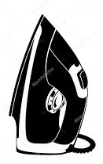
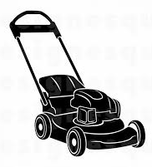
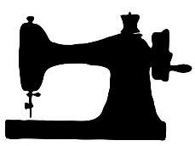
Recycle your unwanted tools and equipment
to enable others to help themselves.
The Developing World Group and Live Simply Group are supporting WORKAID.
WORKAID collects old tools, haberdashery items and gardening equipment. Their team of volunteers then refurbish and ship them to vocational training projects in Africa and the UK. This is to help disadvantaged people learn trade skills and start up their own business. Some are also sold in the WORKAID shop.
Please drop-off* any of the items listed overleaf to:
Our Lady of Lourdes Church (Undercroft entrance),
Rothamstead Avenue, Harpenden.
On: Sunday 13th October 2019
Between: 12.30pm and 5pm
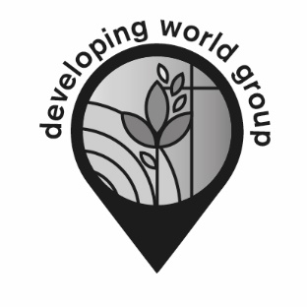
*If an item is too large for you to transport we can come and collect it.
Please call John Buck on 01582 712248 or email: buckjohn977@aol.com
www.Parish.rcdow.org.uk/harpenden/parish-groups/
Registered Charity Number: 233699
www.workaid.org
Registered Charity Number: 1041574
Supporting small projects to make a BIG difference

