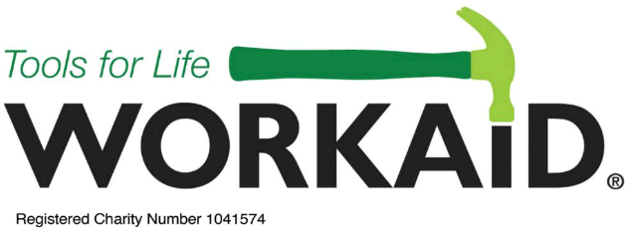

List of recyclable Tools and Equipment wanted.
Please deliver to Our Lady of Lourdes, (Undercroft entrance), Harpenden,
on Sunday 13th October 2019, between 12.30pm & 5pm,
to support WORKAID.

Sewing Machines | All makes, any age, including vintage/antique sewing machines.  Manual, Treadles, Overlockers, Industrial.
Haberdashery | Everything for sewing eg: cotton fabric, leather, reels of thread, scissors, pins, needles, lace, ribbon, elastic, zip, buttons.
Knitting Machines | Electric and manual knitting machines if complete with instruction booklets.  (Accessories must be labelled as part of machine, eg: box 1 of 3)
Wool | Hand knitting wool; cones for knitting machines; knitting needles & patterns.
Tools etc. | Carpentry tools, woodworking machinery – saws, lathes, routers, planers, etc.  Plumbing tools; Motor mechanic tools;  Masonry & Bricklaying tools; Electricians tools & machines; Cobbler/leatherwork/upholstery tools; Blacksmith tools; Metalwork & Engineering workshop tools & machinery – lathes, drilling, milling machines, etc;  Welding machines (MIG & arc);  Green woodworking tools – adzes, draw knives, forks etc.
Horticultural | Spades, shovels, forks, shears, hand trowels & forks, long handled hoes (all with sound, undamaged handles, please); Electric garden tools in working order;  Petrol lawn mowers, hedge trimmers, strimmers and chain saws;  Watering cans, sprayers, pumps (all kinds) and hosepipes.
Typewriters | Manual typewriters only.
Miscellaneous | Personal Protective Equipment (gloves, masks, etc.) in original packaging;  Ironmongery – screws and nails, bolts, hinges, locks. Also solder & flux.  Electric Irons!

