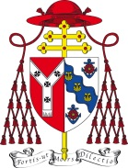

Pastoral Letter for the Sixth Sunday in Ordinary Time
13-14 February 2021

Shortly it will be Ash Wednesday, a day rich in associations and symbolism. It marks the beginning a Lent, a time for turning again to the practice of our faith, in prayer, self-denial (fasting) and practical generosity (almsgiving). Ash Wednesday is the doorway into this season of renewal.

As we cross this threshold we customarily receive ashes on our foreheads, in the sign of the cross. This is a public mark of our turning again to God, seeking his mercy, forgiveness and help. We use these words: ‘Remember that you are dust, and to dust you shall return’. Yes, we cannot pretend otherwise. Or: ‘Repent, and believe in the Gospel’. Yes, we seek the one thing that is absolutely necessary: the grace of God.

This year receiving ashes in church is going to be difficult. Yes, our churches are safe if the protective measures are fulfilled. But we must all be very careful about travelling too far. Some churches will of course be open for the celebration of Mass as usual. But I have asked them not to make extra provision for Ash Wednesday. We must be so careful and cooperative in the measures we must take, to protect ourselves and to protect others.

I now want to emphasise an important point. Receiving ashes is an outward sign of an inner step, a movement of the heart towards our beloved Lord. This year I invite you to concentrate much more on this inner, spiritual movement than on its outward manifestation in the imposition of ashes.

My suggestion is this: celebrate Ash Wednesday at home, with your family, in the household or ‘support bubble’ of which you are a part. Gather for a while. Read the prayer which I offer. Bless each other by making the sign of the cross on each other’s forehead. Spent some time praying in a way that you know. But please, make this a prayer of your heart for God’s mercy upon this world struggling to cope with the terrible pandemic and the devastation it is bringing.

Here is a prayer:

‘Lord God, with all our hearts we beseech you: have mercy on your people; spare your people; strengthen all people in the struggle against the havoc of this pandemic. Lord our God, without you we are so weak and our courage so limited. Give us your strength; give us your love; give us wisdom and skill to continue this fight. Spare your people, O Lord we pray. Comfort those who mourn and gather into your kingdom all who have died. We make this prayer through Christ our Lord, who died and rose to life, who lives and reigns with you, for ever and ever. Amen.’

Then, bless each other, using one of the two traditional formulas I have quoted earlier in this letter. Then continue with your own prayers. A pattern is suggested at the end of this letter.
As a child, my mother or father used to come to my bedside each night to settle me for sleep. I was kissed goodnight and then, either my Mum or Dad would make the sign of the cross on my forehead. They gave me their blessing. This brought me such security. I remember it to this day. Then I slept in peace.

So please do not hesitate, within your household or ‘bubble’, to bless each other on this Ash Wednesday. We do well to remember together our need of the good Lord. Together, and through each other, he wants to comfort and reassure us of his loving presence. If, on this day, we set aside every pretence that we can do everything of ourselves, then we create in our hearts and lives the space for God’s grace and strength to find a home in us.

This is the great invitation of Ash Wednesday and of the weeks of Lent which follow. Please do take up this invitation. Open your hearts to the gift of God’s presence to support, comfort and strengthen you. This year, it may be best to do this, not by going to church, but by sharing the prayer, the blessing and this moment of dedication within the love of your family and friends.

Please do include me in your prayers, too.

May God bless you all,
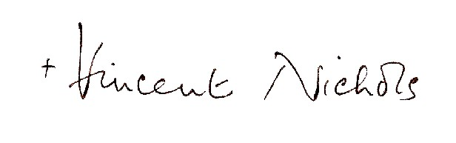
Cardinal Vincent Nichols
Archbishop of Westminster

Ash Wednesday at Home

- Gather together and start with the Sign of the Cross.
- Read the Gospel for today. It is from St Matthew’s Gospel, 6.1-6 and 16-18.
- Say together the prayer given in this Pastoral Letter.
- Make the Sign of the Cross on each other’s forehead, using the words you choose.
- Pray together: the Our Father; the Hail Mary; each one with his or her own prayer or intention.
- Conclude with the ‘Glory be to the Father...’
- Give each other a sign of peace.

So Lent begins!

