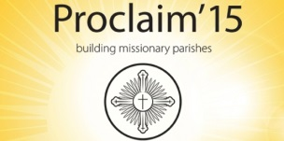

NAME:
EMAIL ADDRESS:
TEL NO
I would like to be a part of Proclaim ’15. The project (s) I want to be involved with are below (please tick all that are appropriate)
Project 1  Youth initiatives | Project 2  Reaching out/housebound /end of life care support | Project 3  Adult formation post RCIA/ Marriage and relationships
(a) Phase support  (b) Post confirmation  (c) Post first Holy  communion | (d) Relaunch FD Helpline  (e) Reach out to  Housebound  (f) End of life care support | (g) Post RCIA support  (h) Faith development  courses  (i) Marriage and  relationships

Please email to trishbonnett@rcdow.org.uk or post into box in church porch. Thank you so much for your help with this.

