The Stations of the Cross

Before each station we recite

We adore you, O Christ, and we bless you, because by your holy cross, you have redeemed the world.

After each station we walk in silence to the next station

First Station  Jesus Condemned  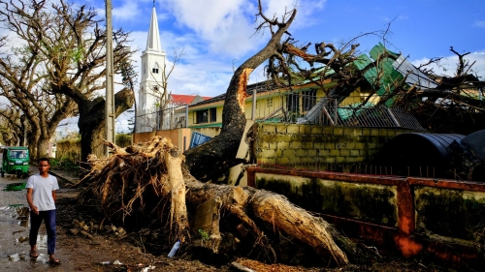 | Pilate said to them, ‘Then what should I do with Jesus who is called the Messiah?’ All of them said, ‘Let him be crucified!’  The earth is crying out because of the harm we are causing. (Laudato Si’ #2)  Jesus sets out on his path of suffering at the hands of humankind – our hands. God sent us his only son as a great gift, yet we condemned him to death. It seems we are making the same mistake with God’s gift of creation. Human beings are polluting the land, the oceans and the air.  Pause for reflection  May we learn to treat the good things God spreads before us with love and respect.  We reply: Lord, help us to protect our shared home and to live as one single human family, full of goodness and beauty.
Second Station  Jesus carries his cross  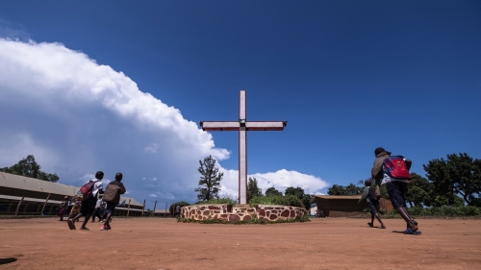 | “After mocking Jesus, the soldiers stripped him of the robe and put his own clothes on him. Then they led him away to crucify him.” Matthew 27:28-31  The climate crisis is worst for the poor, yet they have done least to cause it. Like Jesus, they carry the cost of our actions. Climate change is hitting the poorest hardest. They are bearing the worst of severe weather events like droughts and floods, and have little to fall back on when disaster strikes. Yet greenhouse gas emissions have mostly been caused by richer nations. We can’t stand by while others suffer for our actions. Let us demand change from our leaders to reduce emissions fast.  Pause for reflection  We feel sorrow for the times when we have failed to understand how our actions impact others.  We reply: Lord, help us to protect our shared home and to live as one single human family, full of goodness and beauty.
Third Station  Jesus falls for the first time  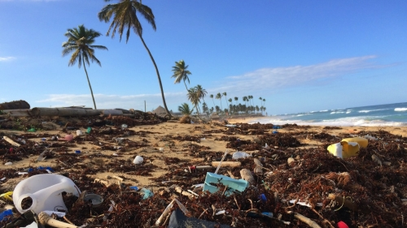 | “He was wounded for our transgressions, crushed for our iniquities; upon him was the punishment that made us whole, and by his bruises we are healed.” Isaiah 53:5  “Never have we so hurt and mistreated our common home as we have in the last 200 years.” (Laudato Si’ 53). Our world is fragile, entrusted by God to human care. We must be careful with the power we have over it. (Laudato Si’ 78)  Pause for reflection  May we each do our part to reduce our carbon footprint through  our daily actions.  We reply: Lord, help us to protect our shared home and to live as one single human family, full of goodness and beauty.
Fourth Station  Jesus meets his mother  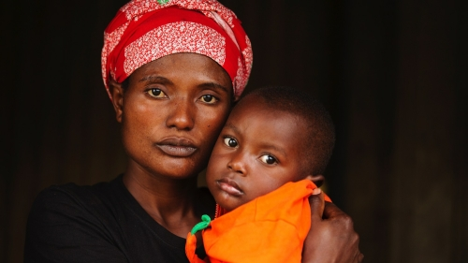 | “a sword will pierce your own soul too.” Luke 2:35  Mary is the Mother and Queen of all Creation, who grieves for the sufferings of the poor and for the creatures of this world. (Laudato Si’). Mary grieved for her son at the foot of the Cross, but as Pope Francis says: “she shared his suffering, yet was not overwhelmed by it. She was the woman of strength who uttered her ‘yes’.” (Speech in Panama 2019, quoted in Christus Vivit.). Mary accepted what God asked of her, despite the risks. She didn’t think twice.  Pause for reflection  We ask Mary to watch over us, her children, as we try to say yes to all that God asks of us.  Hail Mary…
Fifth Station  Simon Helps Carry the Cross  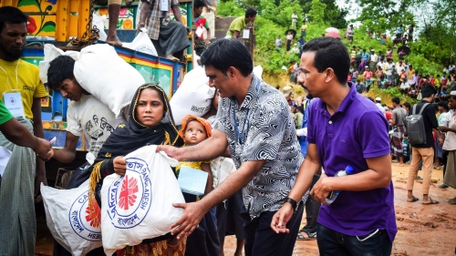 | “The soldiers compelled a passer-by, who was coming in from the country, to carry his cross.” Mark 15:20-21  God asks everything of us, yet at the same time he offers everything to us. (Evangelii Gaudium 12). Jesus is too weak to carry the great weight of the cross up the hill of Calvary. Simon takes the heavy burden from him, although he must have been afraid to show support for a man condemned to death. God can put very demanding and challenging tasks in front of us, yet also gives us the joy and courage to meet those challenges.  Pause for reflection  Let us pray for the strength to help others, even when it seems risky or difficult. Pope Francis gives us this promise: “our hearts expand as we step out of ourselves and embrace others.”  (Fratelli Tutti 89)  We reply: Lord, help us to protect our shared home and to live as one single human family, full of goodness and beauty.
Sixth Station  Veronica wipes Jesus' face  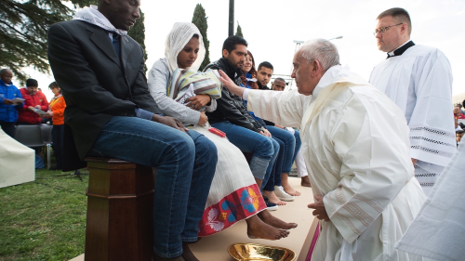 | ‘Truly I tell you, just as you did it to one of the least of these who are members of my family, you did it to me.’ Matthew 25:40  Let us not miss out a kind word, a smile, or any small gesture which spreads peace and friendship. (Laudato Si’ 230). Veronica is another bystander in Jerusalem, who is moved by Jesus’s suffering to step forward and wipe his tired face. Pope Francis tells us the value of practising simple daily gestures that show we care for one another.  Pause for reflection  May we reach out to others with everyday acts of love. Let’s live as one single human family.  We reply: Lord, help us to protect our shared home and to live as one single human family, full of goodness and beauty.
Seventh Station  Jesus falls the second time  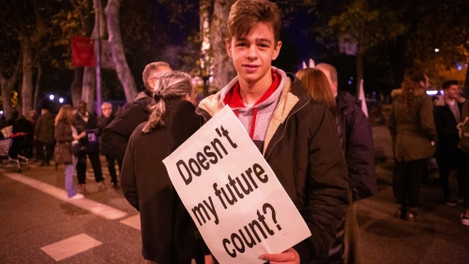 | “You have lived on earth in luxury and pleasure; you have fattened your hearts for the day of slaughter.” James 5:5-6  In a throwaway culture, young people themselves end up being discarded. (Christus Vivit 78). Pope Francis warns of the destruction caused by our throwaway culture, which makes us want more and more without thinking of the cost to others, to the environment, and to our own inner selves. The emptier our hearts, he says, the more we need things to buy to try and fill the space. We need a better way.  Pause for reflection  Let us be open to change our lifestyles and live more simply, to find true and lasting satisfaction.  We reply: Lord, help us to protect our shared home and to live as one single human family, full of goodness and beauty.
Eighth Station  Jesus meets the women  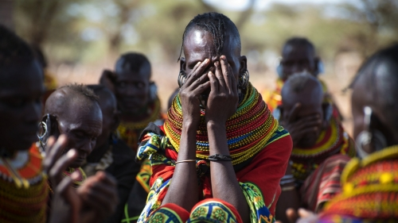 | “Among them were women who were beating their breasts and wailing for him.” Luke 23:28  Dare we turn what is happening in the world into our own personal suffering, and so discover what we can each do about it? (Laudato Si’ 19). A group of women in the crowd mourn for Jesus as they follow him on the way to his death. They share in his pain. We too can feel sad and helpless, when we see what is wrong in our world.  Pause for reflection  May we always believe that we can make a difference, when we act with love.  We reply: Lord, help us to protect our shared home and to live as one single human family, full of goodness and beauty.
Ninth Station  Jesus falls the third time  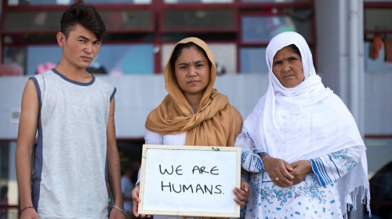 | “Take my yoke upon you, and learn from me; for I am gentle and lowly in heart, and you will find rest for your souls. For my yoke is easy and my burden light.” Matthew 11:28-30  Billions of people, the excluded, frequently remain at the bottom of the pile. (Laudato Si’ 49). Humanity, it seems, has disappointed God’s expectations. But Jesus, who knows how it feels to struggle and to fall, always holds out his hand to offer us hope. As Pope Francis says, “No one is useless and no one is expendable.” (Fratelli Tutti 215)  Pause for reflection  May we always include those who are left out or feel worthless. No one should be cut off from the love and care they need to live a happy life.  We reply: Lord, help us to protect our shared home and to live as one single human family, full of goodness and beauty.
Tenth Station  Jesus is stripped  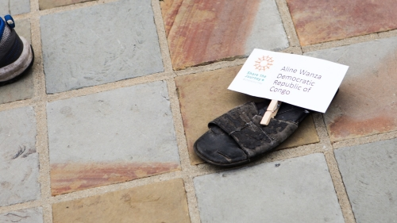 | “The soldiers took his clothes and divided them into four parts, one for each soldier.” John 19:23  “Not to share our wealth with the poor is to rob them and take away their livelihood.” (St John Chrysostom, Fratelli Tutti 119). These soldiers seem heartless, yet how poor must these men be, who scramble over the simple clothes of a wandering prophet.  The earth is a shared inheritance, says Pope Francis, whose fruits are meant to be shared by everyone. (Laudato Si’ 93)  Pause for reflection  May we never be content with a world where the rich few enjoy so much, at the expense of the poor. Let’s not take more than our fair share of the earth’s resources.  We reply: Lord, help us to protect our shared home and to live as one single human family, full of goodness and beauty.
Eleventh  Station  Jesus is nailed to the cross  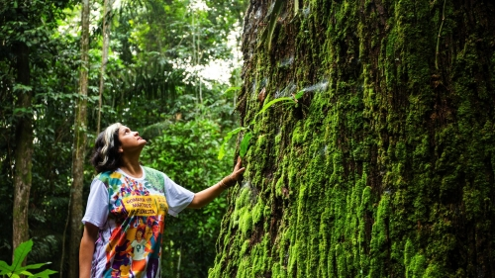 | “When they came to the place that is called The Skull, they crucified Jesus there with the criminals, one on his right and one on his left.” Luke 23:33-34  Let me say this once more: God never tires of forgiving us. (Evangelii Gaudium 3). One of the thieves is sorry for what he has done and sees the goodness in Jesus. We may not always have done our best to care for each other and for the earth, but it’s never too late to change.  Pause for reflection  May we always turn back to God whenever we are lost. He never tires of forgiving us.  We reply: Lord, help us to protect our shared home and to live as one single human family, full of goodness and beauty.
Twelfth Station  Jesus dies  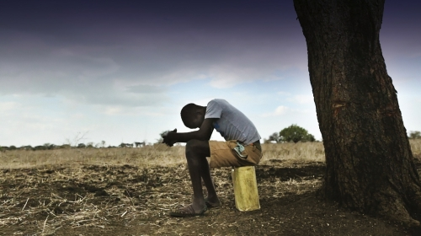 | “Jesus cried out with a loud voice, ‘Eloi, Eloi, lama sabachthani?’ which means, ‘My God, My God, why have you forsaken me?’… Then Jesus gave a loud cry and breathed his last.” Mark 15:34, 37  The Creator does not abandon us. He never forsakes his loving plan, or repents of having created us. (Laudato Si’ 13). When we think of everything that is wrong in the world – poverty, injustice, climate change – we can feel despair. Yet as Pope Francis tells us, God never regrets having created us.  Pause for reflection  May we keep faith, even in the darkest times, and know that God loves and values each of us.  We reply: Lord, help us to protect our shared home and to live as one single human family, full of goodness and beauty.
Thirteenth Station  Jesus is taken down from the cross  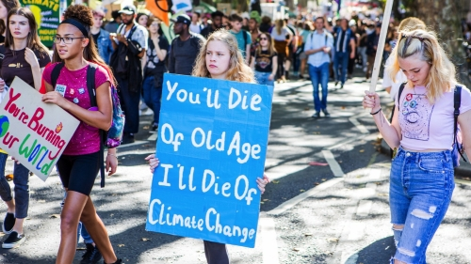 | “Joseph of Arimathea, who was a disciple of Jesus, though a secret one because of his fear of the Jews, asked Pilate to let him take away the body of Jesus.” John 19:38  Please, do not leave it to others to be protagonists of change. (Christus Vivit). Joseph is afraid, but his love for Jesus makes him act anyway. We must do what we know is right, even when it is difficult.  Pause for reflection  May we always work for the good of all and stand up against injustice.  We reply: Lord, help us to protect our shared home and to live as one single human family, full of goodness and beauty.
Fourteenth Station  Jesus is buried   | “Joseph bought a linen cloth, and taking down the body, wrapped it in the linen cloth, and laid it in a tomb that had been hewn out of the rock.” Mark 15:45  We come together to take charge of this home which has been entrusted to us. (Laudato Si’ 244). While the body of Jesus lies in the tomb, the disciples are full of fear. They hide, they wait. Yet soon they must find the courage to go out and change the world. This is our future as a people of God.  Pause for reflection  May we overcome our fears and play our part in making the world a better place.  We reply: Lord, help us to protect our shared home and to live as one single human family, full of goodness and beauty.

Concluding Prayer
O God, Trinity of love,
grant that we Christians may live the Gospel,
discovering Christ in each human being
recognising him crucified
in the sufferings of the abandoned
and forgotten of our world
and risen in each brother or sister
who makes a new start.

Come, Holy Spirit, show us your beauty
reflected in all the peoples of the earth,
so that we may discover anew
that all are important and all are necessary,
different faces of the one humanity
that God so loves. Amen. (Prayer from Fratelli Tutti)

