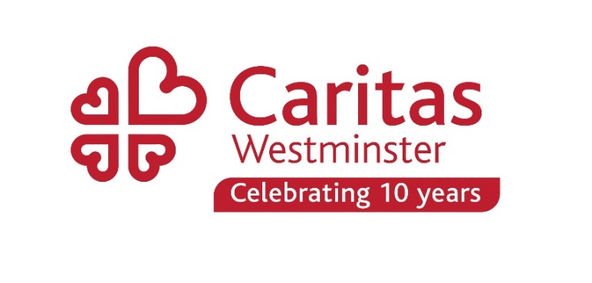
News from Caritas Westminster for priests and parishioners

Dear fathers and colleagues
June is a busy month at Caritas Westminster. We began by celebrating Volunteers Week (1-7 June) and will end by celebrating the 8th anniversary of Caritas Bakhita House. In between we have Refugee Week and Learning Disability Week (both next week 19th-25th June) and we are looking forward to welcoming 16 schools to Westminster Cathedral this Friday for a Caritas festival – schools which have been involved in our Caritas Ambassadors and/or Imagining Futures Programmes.

Refugee Week 19th - 25th June: Compassion
Monday June 19th is World Refugee Day, and kicks off Refugee Week. The theme for Refugee Week 2023 is Compassion.
Attached with this email are a poster which you could print out and display, and a document containing more information and a short talk which you could ask a parishioner to read after your Masses on 18th* or 25th June, or during the week, to share the message of the CBCEW's new teaching document 'Love the Stranger'.
We also have a set of bidding prayers which you can adapt and use during refugee week, which were created by the Justice and Peace group in Hanwell. These, along with other information about Refugee Week, and Caritas Westminster’s work with migrants and refugees, can be found on our website here.
Or click here for an alternative set of bidding prayers from the Westminster Justice and Peace web page (produced last year)
*We realise that 18th June is the Day for Life which will of course take precedence in most parishes, but we hope you find time to think and pray for refugees, during and after Refugee Week

Learning Disability Week
Next week is also Learning Disability Week, which will be celebrated at Caritas St Joseph’s with an exhibition of art and crafts on Tuesday.
The Outreach team at St Joseph’s are currently supporting 19 children with learning disabilities prepare for the their First Holy Communion across 14 parishes in the Diocese. We are also preparing 4 young people to receive their confirmation.
On September 17th 2023 there will be a relaunch of the Kingsland parish Saturday Club including an Inclusive Mass and lunch. The club will be open to all people with learning disabilities and their families in the parishes in the East End. More details to follow.
There are currently Saturday Clubs running in Burnt Oak, Palmer’s Green and the Allotment.
Please let us know if there are any young people with learning disabilities in your parish who might need support in preparing for the sacraments in the new year. We can also offer resources and training for catechists through our Symbols of Faith Courses.
For more information on all outreach work from Caritas St Joseph’s please contact Paul Christian: paulchristian@rcdow.org.uk

Caritas supermarket vouchers scheme – Summer voucher round for parishes is opening 26th June
Parishes will once again be able to request £300-worth of supermarket vouchers from the above scheme, that you can distribute as you wish amongst your community.
If you have not been on the scheme in the last 12 months, and do not receive emails from Niki Psarias at Caritas Food, and want to join, please email cfc@rcdow.org.uk (there may be a slight delay replying to you due to staff annual leave, but we will get back to you as soon as we can).
If you have been on the scheme and accessed vouchers in the last 12 months, you will automatically receive an email on 26th June when the round opens.
The vouchers themselves will be sent via email in the week commencing 17th July.

Appreciating those who serve in our parishes
Many thanks to all of you who sent thank you messages showing appreciation of your volunteers, to the Caritas Volunteer Service. You can read all the messages here. There are many different ways you can recognise the service of your volunteers and those who are in ministry in your parish – and anything you do to affirm people really does help with retention and recruitment. The Caritas Volunteer Service is here to help: email cvs@rcdow.org.uk

Cost of Living Corner!
Our monthly slot with tips for those supporting parishioners struggling with the rising cost of living.
We are working with some other organisations to provide expert online training sessions and support for people in parishes, schools, SVP Conferences and projects, who are assisting those who are struggling financially. At the moment you can sign up for:
Budget Coach training – either in July or September. For volunteers and staff in parishes, schools and projects who want to help people who are struggling to manage their money
For more details and to register
July: https://www.caritaswestminster.org.uk/building-up-firm-foundations-budget-coach-training-1513.php
Sept: https://www.caritaswestminster.org.uk/building-up-firm-foundations-budget-coach-training-1512.php

Loan Shark Awareness: This session is designed to help you to understand exactly what a loan shark is, help you spot the signs that somebody you know may be the victim of a loan shark and how you can help them by working with the experts.
https://www.caritaswestminster.org.uk/loan-shark-awareness-training-1514.php

Recent research from Sustain, shows that over 200,000 families are missing out on the Healthy Start Scheme, which we mentioned in April’s bulletin.
This scheme provides help with buying healthy food and milk, and is open to people receiving Universal Credit or Child Tax Credits, who are pregnant or have a child under 4. Find out more here - https://www.healthystart.nhs.uk/
Read the research from Sustain here: https://www.sustainweb.org/news/apr23-families-miss-out-68-million-healthy-start/

Self-reliant Groups
These are ways to build community, connection, friendship and even income. If you are interested in looking into this for your parish, there is a webinar next Wednesday from Purple Shoots and Church Action on Poverty. Follow this link for more information and to sign up: https://www.eventbrite.co.uk/e/an-introduction-to-self-reliant-groups-for-churches-tickets-625188213777

Free School Meals for All Campaign
We are supporting this campaign to ask the Government to provide free school meals for every child from nursery to sixth form – seeing this as an essential part of education just like books and desks. There is a Bill going through parliament at the moment which is aiming to achieve this for primary schools. See: Free school meals for all Primary Bill – led by Zarah Sultana MP for Coventry South. The second reading is on 30th June.
You can support us by asking parishioners to sign their name in these two places:
From Sustain: Add your name to this map to show your support for universal access to free school meals for all children up to sixth form: https://www.sustainweb.org/school-food-for-all/
Signatures will be delivered to Government.

From the National Education Union: Add your name to this open letter to Rishi Sunak, calling for an end to the postcode lottery where some primary school children receive free school meals and some do not: https://freeschoolmealsforall.org.uk/take-action
Signatures will be delivered to Government.

Caritas Europa recently celebrated its 30th anniversary and produced this 3 minute video, which gives a glimpse into the work of Caritas across the continent.

Upcoming Events
Please include the following in your parish newsletters if appropriate or forward to relevant parishioners

Praying for migrants and refugees, and for our policy leaders
You are warmly invited to join our monthly prayer vigil in front of the Home Office, particularly at the beginning of Refugee Week on Monday 19th June from 12.00 to 1.30pm. Bishop Paul McAleenan, Bishops' spokesperson for Migrants and Refugees, will lead the reflection. Meet at 2 Marsham Street, SW1P 4DF.
If you can't make it to Central London, you are invited to pray in local groups and churches. Email barbarakentish11@gmail.com or johanmaertens@hotmail.com to receive the prayer sheets, and join in solidarity with our prayers.

Summer Barbecue at Caritas St Joseph’s
A fundraising event for Caritas St Joseph’s. Saturday 15 July 12:30-4:00pm at St Joseph’s Grove, the Burroughs, Hendon, NW4 4TY. £15 , or £8 for carers, £5 for children. Email adelazahab@rcdow.org.uk to book your tickets.

Diocese of Westminster Seniors Network - Understanding and alleviating social isolation and loneliness
Tuesday 4th July 2023, 11:00 - 12:30, online.
At the Animating Seniors Groups conference organised by Caritas Westminster and the Irish Chaplaincy, combatting loneliness was one of the topics people most wanted to focus on. Join us to explore opportunities to address social isolation and loneliness in your community, especially among people in later life.
Summer Picnic for all involved with food projects
Saturday 8th July 2023, 1:00pm St James's Park (meet at Charing Cross)
Everyone involved with any type of outreach project involving food in the diocese, is invited to join Caritas Westminster’s food network for a picnic in the park. Some food will be provided, RSVP is essential – please email cfc@rcdow.org.uk

Routes out of Homelessness - Dignified Work Series – introducing Beam
Friday 21st July 2023, 10:00 - 12:00, online
For anyone involved in outreach projects for those experiencing homelessness – this is a chance to find out about Beam, a charity which supports people into jobs and homes that lift them out of homelessness for good. Find out more and sign up here: https://www.eventbrite.co.uk/e/routes-out-of-homelessness-stepping-stones-dignified-work-series-tickets-479859752437

