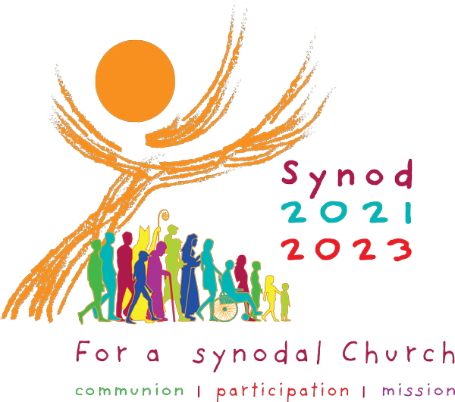

THE SYNODAL PATHWAY

My name is Michel Jordan.
Fr Julian has invited me to be the Parish Representative for the Synodal Pathway. This is an initiative from Pope Francis and is being conducted in all churches around the world. The Vatican website and closer to home, the Westminster Diocese website have detailed information on this, but I have picked out one line which sums it up very well:
It is intended to inspire people to dream about the church we are called to be, to make people’s hopes flourish, to stimulate trust, to bind up wounds, to weave newer and deeper relationships, to learn from one another, to build bridges, to enlighten minds, warm hearts, and restore strength to our hands for our common mission.
Now, you may be wondering what this really means. Well, it is an opportunity for each one of us to reflect and express our thoughts, both positive and negative, on our parish, our church services and our mission.
As we come out of a series of lockdowns and with a new parish priest in Fr Julian, this is an ideal opportunity for all of us, whether or not we attend church, to share our thoughts, to help Fr Julian shape his ministry with us in a way that fulfills our needs.
On the back of this page, you will find 6 simple questions for you to reflect on and answer. This is not an intellectual exercise, nor are we here to challenge the teachings of the church. It doesn’t matter if you can’t answer all of them. Just write simply what comes to mind. There are no right answers, no wrong answers; there is no judgement.
The second part of the exercise, when we’ll share and explore the result of our findings, will be organized in December and more information will be given nearer the time.
Please feel free to pick up additional copies of the questionnaire for spouses, children, relatives and friends and return them in the box at the back of the church.

What for you are the strengths of the parish?

What for you are the weaknesses of the parish?

What would you like to see most changed in our parish?

How has the pandemic affected your faith?

If the parish offered you more support, what could it be?

Are there any gifts and talents that you have and would like to offer in support of the church’s mission?

Please feel free to add any additional comments, your name if you wish to, and return it in the box provided at the back of the church by the 29th November. The responses will be summarised and presented at one or more parish meetings where there will be an opportunity to discuss them further.

Would you like to attend one of these meetings: Yes/No
If yes, what would your preference be: Weekday morning. Afternoon. Evening.
Please circle your preference

Should you wish to speak to someone in person, please contact the presbytery on 01992 440986
Thank you for your contribution

