Parish of St. Michael & St. Martin
94 Bath Road, Hounslow, TW3 3EH
Tel: (020) 8570 1793 Website: http://parish.rcdow.org.uk/hounslow/
Email: colettejoyce@rcdow.org.uk

This Parish is part of the Westminster Roman Catholic Diocese Trust. Charity No. 233699

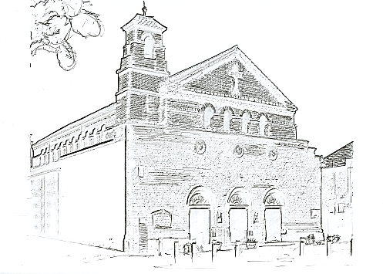

First Holy Communion 2018-19

***Parents Only Introductory Meeting in Parish Centre –
Saturday, 15th September 2018, 10:30-11:30am***

Sessions for Children and Parents
Parish Centre / St Mark’s School

1 – Eucharist 1 Saturday, 29th September 2018, 10:30am-12noon

2- Eucharist 2 Saturday, 13th October 2018, 10:30am-12noon

3 – Eucharist 3 Saturday, 10th November 2018, 10:30am-12noon

RITE OF ENROLMENT: Sunday, 11th November 2018, 2:00pm Mass

4 – Reconciliation 1 Saturday, 24th November 2018, 10:30am-12noon

5 – Reconciliation 2 Saturday, 8th December 2018, 10:30am-12noon

6 – Reconciliation 3 Saturday, 12th January 2019, 10:30am-12noon

7 – Reconciliation 4 Saturday, 26th January 2019, 10:30am-12noon

8 – Reconciliation 5 Saturday, 9th February 2019, 10:30am-12noon

Celebration of RECONCILIATION: in Parish Centre - Saturday 9th March 2019, 10:30am-12noon

9 – Eucharist 4 Saturday, 23rd March 2019, 10:30am-12noon

10 – Eucharist 5 & 6 Saturday, 27th April 2019, 10:30am-12noon

RITE OF ACCEPTANCE: Sunday, 5th May 2019, 2:00pm Mass

THANKSGIVING MASS: Sunday, 9th June 2019 @ 2:00 – 4.30pm
Followed by a PARTY in St. Marks Assembly Hall

There will be six First Holy Communion Masses on three Saturdays in May/ June. The rehearsal for each First Holy Communion Mass will take place in the church on the Tuesday beforehand.

You will be invited to pick a selection of up to 3 dates/times before Christmas.

We will try to accommodate your first choice but please be prepared to be flexible.

There is a limit of 20 children at each Mass.

First Holy Communion Masses and Rehearsals
REHEARSALS IN CHURCH | FIRST HOLY COMMUNION MASSES
1. 3.45-4.40pm Tuesday 7th May 2019 | 1. 11.00am Saturday 11th May 2019
2. 4.45-5.40pm Tuesday 7th May 2019 | 2. 1.30pm Saturday 11th May 2019
3. 3.45-4.40pm Tuesday 14th May 2019 | 3. 11.00am Saturday 18th May 2019
4. 4.45-5.40pm Tuesday 14th May 2019 | 4. 1.30pm Saturday 18th May 2019
5. 3.45-4.40pm Tuesday 28th May 2019 | 5. 11.00am Saturday 1st June 2019
6. 4.45-5.40pm Tuesday 28th May 2019 | 6. 1.30pm Saturday 1st June 2019

Children and Parents are both expected to come to the rehearsals.

.
Family and Friends are all most welcome to attend the FHC Masses.
One bench will be reserved per family. Other guests will be asked to sit at the back of the church.

Updated 25th September 2018 - CJ
E-mail: colettejoyce@rcdow.org.uk
Catechists Office number: 020 8570 1693 (ext 5)

