Church of St John the Evangelist, Islington
39 Duncan Terrace, N1 8AL, #020 7226 3277
Parish priest: Fr Rajiv Michael, Asst Priest: Fr Jakub Joszko, Administrator (Mon/Thu/Fri): Grace Wu
Parish Office: islington@rcdow.org.uk, Safeguarding Rep: Frances Rooney (islingtonsg@safeguardrcdow.org.uk)
32nd Sunday in Ordinary Time / Year 1 (Weekdays)

This Week
Weekday masses  Mon-Fri: 10 AM | Sunday masses  Saturday Vigil at 6 PM  Sunday at 9:30 & 11 AM | Confessions  Saturday: 5:30 – 5:50 PM  (and anytime, as possible, on request)
 | Church remains open from 9 AM to 6 PM for private prayer.

Remembrance Sunday
The gospel this week gives us a wake-up call. Ten virgins wait for the coming of the bridegroom. In pretty much all things they are scarily alike; St Augustine notes that they are all virgins, they have kept their hearts chaste for Christ, they have oil and light. The sleep is probably the final sleep of death. And after all their preparation and good works, only five go in. What did the ‘foolish’ ones miss? And will we be caught out at Parousia? (Homily at https://castingfire.wordpress.com).
Death is not something to be feared in Christianity as the second reading reminds us. To meditate on our end is virtuous and helps us order our lives rightly. There is, unfortunately plenty of death around us, people being lost daily in wars being fought right now. As we keep Remembrance Sunday, this weekend, let us pray for the fallen. There will be a two-minute silence at the beginning of the 11 AM Mass. Fr Rajiv

News & Events
Fr Rajiv’s installation: Thanks to all those who have put their names down to help with Fr Rajiv’s installation; a reminder that Fr Rajiv will be officially ‘installed’ as Parish Priest of St John’s and Bl. Sacrament churches by Bishop Nicholas on the 25th Nov, Saturday evening 6 PM. We need the help of Parishioners to volunteer in preparing the crypt and providing food for the evening. We need savoury or sweet food to share on the night. I think some of those who have kindly volunteered are readily recognisable, but we might miss others – if you could leave your email with your name, it would be very helpful. Or drop a line to the Parish Office. Thank you. Many thanks to Michael Fletcher for kindly coordinating this.

Readers and Eucharistic ministers: Thanks to all those who have already given your names. Those still considering can continue to do so, either to Colette Bowe (colette@redrock23.com) for Reading or mail the office to be a Eucharistic minister. We will have a short introduction but a more structured retreat/training day, most probably in the New Year.

First Holy Communion Preparation: FHC preparation starts this week after the 11 AM Mass. A reminder that parents and children are expected to be present at the 11 AM Mass.

Young and younger….
Young Adult’s Group (18-35): I’m leaving the Young Adult’s group QR code on here for the moment, so more people can sign up. There will be mass and a social event for Catholic young adults (from across London) followed by lunch after, at our sister church, Blessed Sacrament, Copenhagen Street on Dec 3rd ,1 PM. Mass will be celebrated by the Franciscan Friars of Renewal (CFR’s).

Upper Room Leadership Programme (18-23) by Westminster: An 8-month programme, starting in December, for young people interested in growing in discipleship, spiritual formation, and practical training, culminating in the diocesan pilgrimage to Lourdes. It’s an opportunity to journey with 20 other young Catholics in developing your unique vocation. Deadline this week (16th Nov). See https://youth.rcdow.org.uk/programmes/upper-room-leadership-programme/

Christian Leadership Formation: Are you currently in Lower Sixth/Year 12? Are you considering a public-facing career? Do you want to grow in leadership skills? The Christian Leadership Formation programme uniquely offers a combination of stimulating and high-quality intellectual content, spiritual nourishment, personal development, inter-personal skills, team building and socials in a tightly-knit community experience, with expert academics and professionals. Open to any student who is motivated by their faith and their studies, with bursaries available as needed. For more information and applications please look at www.christianleadershipformation.com

Not to forget the old…: Those who wish to donate to the Sick and retired priests fund can still do so via the envelopes available or directly, by scanning the QR code on them.

Funerals this week:
Monday 13th November 2023 10:00am at BLESSED SACRAMENT Funeral Mass for Christopher Rynne,
Friday 17th November 2023 10:00am Funeral Mass for Vivienne Mary Ellen Bundy,
Monday 20th November 2023 10:00am Funeral Mass for George Arthur Ward

Islington Church Concerts: The fabulous music on offer at St John’s (and St James’, Prebend Street - with more churches to be added in the future) are promoted on www.islingtonchurchconcerts.org. You can keep yourself updated by signing up for the newsletter on the site. They are looking for a volunteer Technical Administrator who can work with Squarespace and MailChimp. If interested, please contact Jim Carroll (jim.d.carroll@outlook.com).

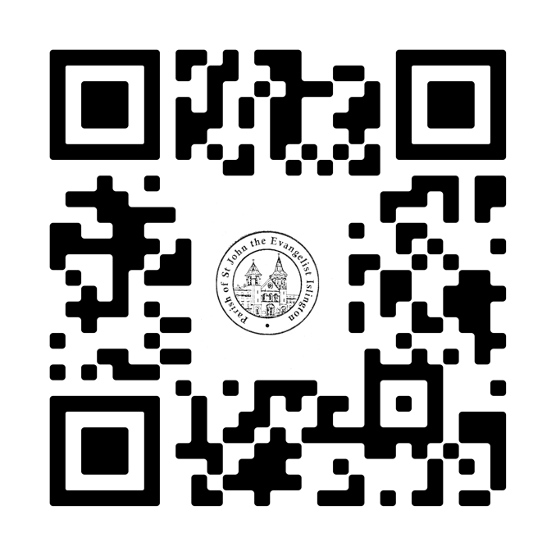
From the Presbytery: Thanks to those who kindly volunteered to help clear up some accumulated junk in the upper rooms; these are spaces which could potentially be used for church meetings, but they need work! Other than our usual structural problems, we have been without any internet connection this last week (all haggling with our provider has been in vain!) If you’ve mailed us, please bear with us for any delay getting back to you. Our phone lines also seem to go down mid-week, so apologies if you were trying to get in touch!

Mass offerings: If you donate via the contactless machines, they will probably not be working due to our lack of connectivity, but you can donate via the site using the QR code. As always, we are very grateful!

