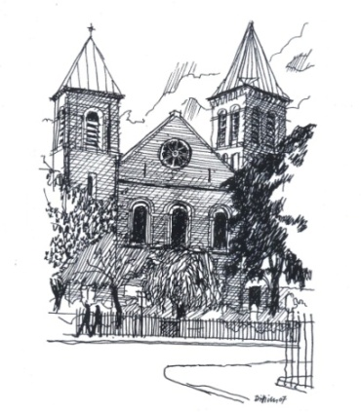

St John the Evangelist Catholic Church

39 Duncan Terrace
Islington
London N1 8AL

Tel. (020) 7226 3277

Confirmation Course 2024
Parishes of St John the Evangelist and Blessed Sacrament

Dear Candidates and Parents,

This year’s Confirmation Course will start on Tuesday 23rd January 2024! We have a wonderful team of committed catechists who will be helping run the programme this year and we are looking forward to welcoming all of you!

Requirements:
- Candidates should be in Year 9 or above
- Registration Form, which needs to be filled out and returned to your parish by Friday 19th January 2024!
- Photocopy of the candidate’s baptism certificate
- Donation of £60 to cover the costs of the material.
If you have any difficulty with this, please speak to Fr. Jakub or Sr. Miriam

Please note: The first meeting with the candidates and parents or caregivers will take place on Friday 19th January 2023 at 7 p.m. at St John the Evangelist Church.

Confirmation Mass will take place on Friday 24th May 2023 at 7:00pm
at St John the Evangelist Catholic Church.

St John the Evangelist Catholic Church
39 Duncan Terrace, London N1 8AL
Tel. (020) 7226 3277

CONFIRMATION REGISTRATION FORM 2023

Dear candidate, this form should be completed personally by you with the help of your parents if necessary. Since you are willing to undertake this journey of maturing in your faith, we remind you that you are expected to attend Sunday Mass regularly throughout the whole period of preparation for Confirmation.

Name of Candidate___________________________________________________

Date of Birth___________________________

Address_____________________________________________________________________________________________________________________________________________________________________________________________________

Home Tel _________________________ Mobile___________________________

Email_______________________________________________________________

Parent’s email_______________________________________________________

School__________________________________________________________________________________________________________________________________

Parish______________________________________________________________

Date and Place of Baptism_____________________________________________

Please supply a Copy of your Baptism Certificate.

Please complete this form and return it to your respective Church (St John the Evangelist or Blessed Sacrament) by Friday 19th January 2023.

Confirmation Mass will take place on Friday 24th May 2023 at 7:00pm
at St John the Evangelist Catholic Church.
The first meeting with the candidates and parents or caregivers will take place on Friday 19th January 2023 at 7 p.m. at St John the Evangelist Church.

Protecting your privacy
Your personal details are required for the specific purpose of processing your Confirmation registration form. This information will be held on file/stored securely on the St John the Evangelist Catholic Church computer for the duration of the programme.

