“Do not abandon yourselves to despair. We are the Easter people and hallelujah is our song.” Pope Saint John Paul II

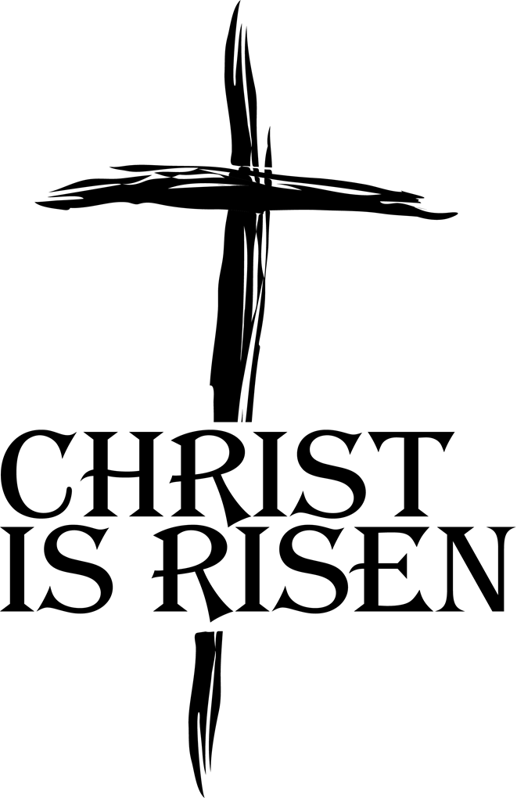
Fr Jimmy wishes you, your family and loved ones
a very Happy and Holy Easter.

St Hugh of Lincoln, Letchworth Garden city
tel. 01462 510015 email: Letchworth@rcdow.org.uk
website: Roman Catholic Parish of Letchworth Garden City – Church of St Hugh of Lincoln RC (rcdow.org.uk)

HOLY WEEK SERVICES 2023
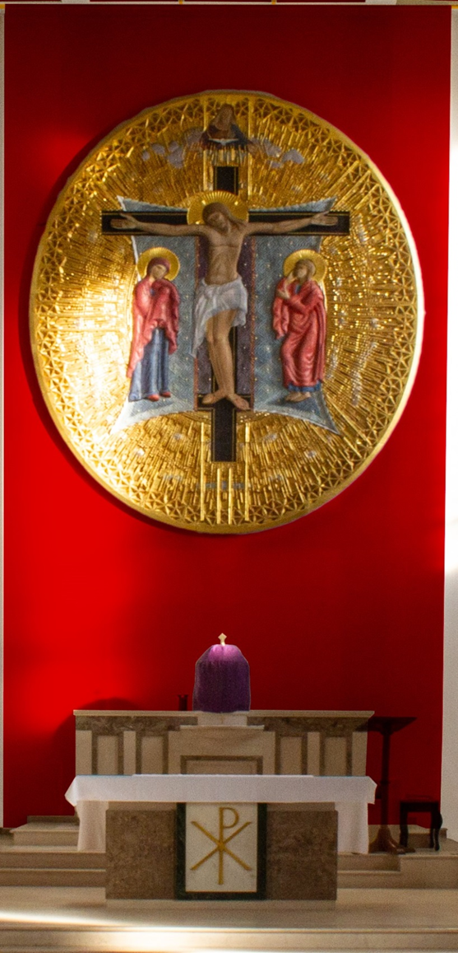
St Hugh of Lincoln, Letchworth

MONDAY 27th March
Polish Lenten Retreat 6pm

WEDNESDAY 29th March
Lenten Reconciliation Service
Priests available for individual Confession 7.30 pm

PALM SUNDAY OF THE PASSION OF THE LORD
Saturday 1st April - Vigil Mass
Gather Outside the Church 6.00 pm

SUNDAY 2nd APRIL
Mass – Blessing of Palms 9.30 am
Gather outside the Church
Mass – Blessing of Palms and Procession
Gather in Fortescue Hall 11.15 am
Mass in Polish 1.00 pm

MONDAY 3rd APRIL
Mass 9.30 am

TUESDAY 4th APRIL
Mass 9.30 am
The Chrism Mass Westminster Cathedral,
with Blessing of Oils and Renewal
of Priestly Promises 12 noon
WEDNESDAY 5th APRIL
Mass 9.30 am

HOLY THURSDAY 6th APRIL
Office of Readings and Morning Prayer 9.00 am

THE SACRED PASCHAL TRIDUUM
HOLY THURSDAY 6th APRIL
Evening Mass of the Lord’s Supper 7.30 pm
Watching at the Altar of Repose until 10.00pm
GOOD FRIDAY 7th APRIL
Office of Readings and Morning Prayer 9.00 am
Children’s Good Friday Service 10.00 am
Walk of Witness (from Broadway Gardens) 11.00 am
Solemn Celebration of the Passion of the Lord 3.00 pm
Solemn Celebration of the Passion in Polish 5.30 pm
Solemn Celebration of the Passion in Polish 7.15 pm

HOLY SATURDAY – 8th APRIL
Office of Readings and Morning Prayer 9.00 am
Blessing of Polish Food (Fortescue Hall) 10.15 to 10.45 am
The Easter Vigil in the Holy Night
and First Mass of Easter
Gather outside Church 8.30pm

EASTER SUNDAY OF THE RESURRECTION 9th APRIL
Mass 9.30 am
Mass 11.30 am
Mass in Polish 1.00 pm

EASTER MONDAY 10th APRIL
Mass 10.00 am
Mass in Polish 1.00 pm

TUESDAY 11th SATURDAY 15th APRIL
Mass 10.00 am

