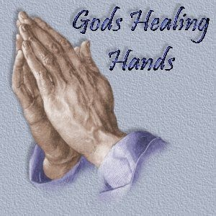

Healing Mysteries of the Rosary

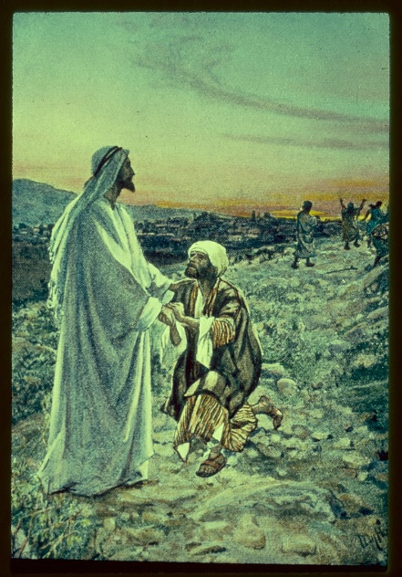
The First Healing Mystery

Jesus restores the outcast to community
“Were not ten made clean? But the other nine, where are they?” (Luke 17:17)
They were lumped together as “unclean.” Nobody knows what afflictions they suffered. These lepers couldn’t be touched, were thrust from home and family, and were forced to live apart. Whatever infected them couldn’t have been worse than this awful isolation, as we know intimately.
Jesus, heal us from this pandemic. Restore our community to health and wholeness. May we remain grateful for the privilege of human gathering.
Our Father
Hail Mary (x10)
Glory Be

Illustration:
Luke 17-17 William Hole commons-wikimedia

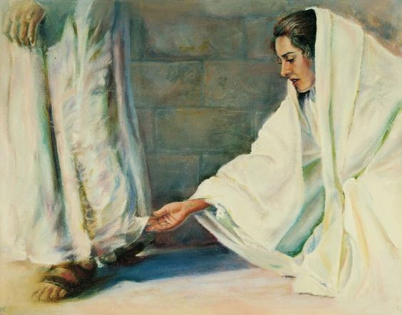
The Second Healing Mystery

Jesus rewards the woman of courage
“Take heart, daughter; your faith has made you well.” (Matt. 9:22)
She wasn’t supposed to be out in public, touching a man’s clothes, or cause a stir that would embarrass her family. But the haemorrhaging woman had suffered too much for too long to behave by social norms that didn’t serve her and couldn’t save her. She trusted Jesus. Good for her!
Jesus, bless the courageous ones who won’t sit quietly by and suffer without taking their destiny in their own hands.
Our Father
Hail Mary (x10)
Glory Be

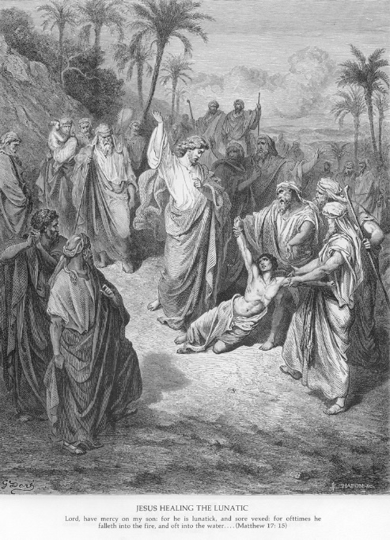
The Third Healing Mystery

Jesus frees the imperilled child
“Lord, have mercy on my son, for . . . he suffers terribly.” (Matt. 17:15)

This poor child fell often into fire and into water. He reminds us of all our children now suffering the effects of conditions they did nothing to cause and are powerless to change.
For all the ways in which the world’s children suffer—hunger, domestic abuse, impaired learning conditions, depression, anxiety, shame— Lord, rescue our children and restore their hope.
Our Father
Hail Mary (x10)
Glory Be
Illustration: 1870. artist Matthew Dore
https://catholic-resources.org/Art/Dore-Matthew.htm

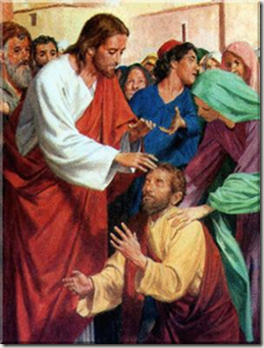
The Fourth Healing Mystery

Jesus heals the person suffering mental distress
“But Jesus rebuked him, saying, ‘Be silent, and come out of him!’ ”
(Mark 1:25)

Demons haunt us all. But some, like this man who cried out to Jesus, are especially burdened. People who are emotionally fragile, or whose mental health was already compromised, suffer exceptionally from the pandemic conditions of stress, upheaval, and isolation.
Lord, we ask you to keep our vulnerable loved ones in your special care. Hold them in the palm of your hand and let them feel your constant protection.
Our Father
Hail Mary (x10)
Glory Be
Illustration:
as appears on : https://prayersandmeditations.com/2013/01/15/reflection-on-mark-121-28-jesus-removes-the-unclean-spirits/

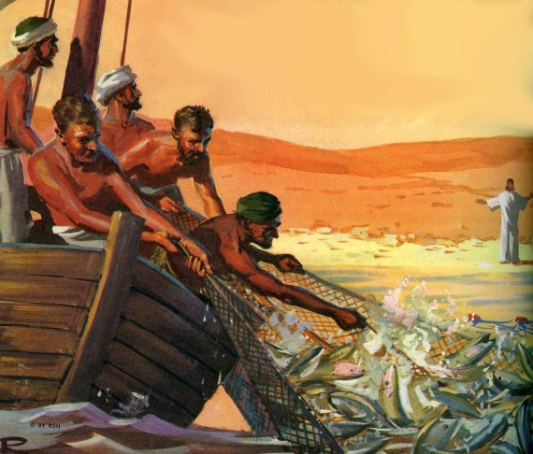
The Fifth Healing Mystery

Jesus heals the Earth’s abundance

“So they cast [the net], and now they were not able to haul it in because there were so many fish.”
(John 21:6)
Behind the realities of pandemic looms the greater danger of a world enduring the cumulative effects of exploitation, greed, indifference, and ignorance. Climate change is changing the rules of our future survival.
Merciful Lord, this creation is your first and best gift to us. Give us the wisdom and the will to transform our global commitment to the planet that is our home.
Our Father
Hail Mary (x10)
Glory Be

Text by Alice Camille, taken from the article “Let’s add 5 healing mysteries to the Rosary” originally posted in the January issue of U.S. Catholic (vol. 86, issue 1, P47-49). Reprinted with permission. The full article can be found at https://uscatholic.org/articles/202101/lets-add-5-healing-mysteries-to-the-rosary/

