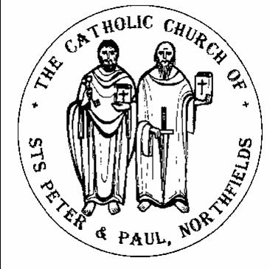 **Catholic Church of Sts. Peter and Paul, Northfields**

*38, Camborne Avenue, Ealing, London, W13 9QZ.* Tel. 020 8567 5421

e-mail: [northfields@rcdow.org.uk](mailto:northfields@rcdow.org.uk); website: <http://parish.rcdow.org.uk/northfields>

Facebook page: <https://fb.me\38camborneavenue>

Parish Priest: Fr. Jim Duffy; Parish Deacon Rev Andrew Goodall

Pastoral Assistant: Anna Maria Dupelycz; Parish Administrator: Rosa Bambury

**Alternative Number:** 07787 048144 (Anna); [northfieldscat@rcdow.org.uk](mailto:northfieldscat@rcdow.org.uk)

**Office Opening Hours Closed**

**Sacraments and Devotions:**

**Sacraments: on enquiry; devotions : suspended until further notice.**

**In case you are admitted to hospital........**

In light of data protection please indicate on entering hospital that your details are to be passed to the RC Chaplain. Also state that you would like the RC Chaplain to visit you.

Psalter week 1 & 2

__________________________________________________________________________________________________



Easter Sunday Year B

&

2nd Sunday Easter Year B

Sunday 4th April & Sunday 11th April 2021

__________________________________________________________________________________________________

**Readings for This Week (Easter Sunday)** Acts 10:34,37-43, Ps 117:1-2, Colossians 3:1-4; John 20:1-9

**Readings for Next Week (2nd Sunday of Easter)** Acts 5:12-6, Ps 117:2-4, Apocalypse 1:9-13, John 20:19-31

**Readings for 18th April (3rd Sunday of Easter)** Acts 5:27-32, Ps 29:2, Apocalypse 5:11-14, John 21:1-19

**____________________________________________________________________________________**

**Message from Father Jim**

As I write this Easter message to you I have just seen that we have had the hottest day in March for 53 years! The world of nature provides us each year with a perfect understanding of the Resurrection. After the death of Winter comes the new life of growth and renewal. Flowers and plants are showing their beauty all around us and leaves are appearing on the trees again. All my life I have associated the beautiful sight of blossom on the trees and rebirth in nature with the Springtime. It is truly wonderful that in our part of the world Easter always coincides with renewal and rebirth in nature, which gives us an inbuilt understanding of Death and Resurrection.

Easter in the Church is a celebration of the dying and the rising of Christ, who conquered death on the Cross by Rising to life on Easter Day. We are assured of following him through death to life because of the Easter story. Thanks be to God we have been able to celebrate the Liturgies and Solemn celebrations of Holy Week and Easter in our churches, unlike last year when we couldn't do that. All of this is because of the wonderful support and effort of so many people in our parish who have made it possible. our sincere thanks and gratitude go to our ever fabulous stewards and cleaners, those who prepared and decorated the church for Easter, and Anna and Katherine Do Rosario who provided music and singing for the liturgical celebrations.

This last year or so has been very difficult and challenging for all of us. We have come to appreciate our relationships, friendships, freedoms and care and compassion for others in a profound way. It would be good to remember especially those from our parish who have died of the coronavirus, those who are now suffering from it, and those who are recovering with long term effects. Our thanks go out again to all in our parish who are working in the NHS or volunteering in any way to help, may you be truly blessed for your dedication and commitment.

Very best wishes for Easter to you all and I hope you are able to celebrate this great Christian Festival with your loved ones and may God's joy and peace be with you always.

Fr Jim.



**Reflection from Father Hilary. An Easter Celtic Blessing**

The Lord of the empty tomb

the conqueror of gloom

 come to you.

The Lord in the garden walking

the Lord to Marg Magdalen talking

come to you.

The Lord in the Upper Room

dispelling fear and doom

come to you.

The Lord appearing on the shore

giving us life for ever more.

come to you.

**_____________________________________________________________________________________________________________________________________________**

**Celebration of Mass continues**. – **Details of times overleaf.**.

Please be aware that numbers allowed in the church at any one time are restricted, the wearing of face coverings is mandatory (unless exempt), as is the use of hand sanitiser on entry and exit of the building.

Please take a copy of the newsletter to anyone who may not be able to get out. Prayer resources will be replenished on the table at the back of the church.

**Volunteers still needed to help with cleaning and stewarding. Cleaning takes place immediately after Mass has finished.** If you would like to volunteer, please contact Rosa on the parish email [northfields@rcdow.org.uk](mailto:northfields@rcdow.org.uk) or by leaving a message on the office Ansa phone 0208 567 5421 with your contact details. **An estimate of 3 stewards per Mass and 3 cleaners.**

**Test and Trace-** As per government guidelines, we are required to ask parishioners to leave details of names and phone numbers when attending the church. Complete a short form or use the QR code with NHS app.

**Mass Intentions**. Please make your request via email, by calling the parish office or completing a form found at the front of the church.

**Offertory Envelopes** Please post envelopes through the parish office door, or place them in one of the collection baskets at the back of the Church during Masses. Should you wish to switch to standing order: This can be done online via the parish website <https://parish.rcdow.org.uk/northfields/donate/> Should you not have internet access, please contact Rosa, or leave a message on the parish ansa phone.

****Next tax year Offertory Envelopes –** The new set of envelopes are due to begin 11th April. They are available for collection from the church from this weekend whenever Mass is being celebrated until the end of 18th April. Please ask a steward to get your set for you by giving your name. After 18th April, arrangements will be made to deliver them to home addresses. Should you wish to switch to standing order and or gift aid, please e-mail or call Rosa after 12th April. Similarly, should you wish to begin giving my envelope.

**Going Contactless!** You will find our new CONTACTLESS GIVING device in the church entrance and you can now use your contactless debit/credit card, Google and Apple Pay to make a donation. Simply choose the amount or enter the amount you wish to donate and hold your card onto the reader. Look out for the notice.

Donations can also be given on-line, please visit our webpage and go to ‘donate’ button along the top ribbon.

**Safeguarding** Many thanks to Susie Worthington for agreeing to be the new parish Safeguarding rep. She can be contacted on [northfieldssg2@safeguardrcdow.org.uk](mailto:northfieldssg2@safeguardrcdow.org.uk)

**Young CAFOD.** We would like to restart this group and to that end invite interested young people to a Zoom call for 12-18 year olds of the parish and/or their parents. This informal gathering takes place at **5pm, Sunday 11 April**, for young people looking to make a difference on pressing issues around the world. Parents please register interest or queries for their daughters and sons to Joseph Lo at [youngcafodnorthfields@gmail.com](mailto:youngcafodnorthfields@gmail.com). The Zoom link will then be sent to you. Please note: for Safeguarding reasons, for anybody under 16, contact is only possible via an adult’s e-mail and/or mobile, 16 to 18 personal e-mails and/or mobile details require parental consent.

**Masses over the next Fortnight**

**Sunday 4th April (Easter Sunday) Sunday 11th April ( 2nd Sunday Easter B) (Divine Mercy)**

8.00pm *(Sat.)* )(Easter Vigil*)* People of the Parish 6.00pm (Sat.)

9.00amMichael (Ann) 9.00am (Sun.).Theresa (L.D.)

11.15am Mark (1st Ann.) 11.15am Margaret (Month’s Mind)

**No Evening Mass** 6.00pm

**Monday 5th April (Bank Holiday) Monday 12th April**

11.15am Ajit (Sick) 11.15am

**Tuesday 6th April Tuesday 13th April (St Martin I)**

6.00pm Piers (LD) **6.00pm**

**Wednesday 7th April**  **Wednesday 14th April**

11.15am Peter (Ints) 11.15am Johan (L.D.)

**Thursday 8th April Thursday 15th April**

**No Mass**   **No Mass**

**Friday 9th April Friday 16th April**

11.15am Johan (L.D.) 11.15am *Requiem* John Molloy RIP

**Saturday 10th April Saturday 17th April**

**No Morning Mass No Morning Mass**

**Prayers for the Sick** We pray for those suffering from illness and their carers: Mary O’Brien, Barbara Lennon Snr, Teresa Hartnett, Stephania Pullin, Geraldine Davison, Michael Davison, Sylvia O’Connor, Maria da Silva, Dave Mortby, Cerys Edwards, Andrew Chandiram, Ivan Mahon-Smith, Kathleen Walsh, John Zielinski, Maria diMarco, Donna O’Hagan, Ann Hagan, Sankar Ghosh, Margaret Adu, Therese Biks and Colin Kelly, Fr Dan O’Malley. Our Lady, help of the Sick, pray for us.

**Prayers for those Recently Deceased and Anniversaries** We pray for the repose of the souls of Johan Hirth, John Molloy, Piers McKenzie Mair, Theresa Donohue, Margaret Farrell-Berent and all those whose anniversaries occur around this time, including, Michael O’Sullivan, and Mark Ram. May their souls and the souls of all the faithful departed through the mercy of God rest in peace. Amen

**Catechetics (Sacramental Preparation)**

**(**Contact Anna initially on [northfieldscat@rcdow.org.uk](mailto:northfieldscat@rcdow.org.uk) or 07787 048144 with enquiries and queries. **Please include a mobile/phone number with your e-mail enquiry.**

**Baptism**

**For infants** (up to the age of 7), parents need to attend a preparation course prior to baptism. The next course will take place in April.

**For children aged 7 – 14**, a similar process to that undergone by adults is normally followed.

**For adults**, the RCIA (Journey in Faith) process is followed. For further detailed information, contact Anna.

**First Communion** .Next session for children, ‘Peter’ Group, Weds. 21st April, 6.15pm, via Zoom. Should this change, an e-mail will be circulated.

**Confirmation** The next session for ‘Gifts’ group, Sun. 18th April, 4.30pm, via Zoom.

**Journey in Faith (R.C.I.A.)** If you are interested in knowing more about the Catholic faith, please contact Anna. Fortnightly sessions resume for adults (aged 14+) on **Mon.**, 19th April, 8.00pm.via Zoom; children **Mon,** 12th April. 6.00pm6pm

**Aged 16 or over, Catholic and never been confirmed?** If this describes you and you would like to be confirmed, contact Anna in the Parish Office([northfieldscat@rcdow.org.uk](mailto:northfieldscat@rcdow.org.uk)) Sessions will commence after Easter for baptised Catholic adults aged 18 and over who are looking to be confirmed. Please contact Anna as a matter of urgency so appropriate arrangements can be made

**Catechists** There is a need to build up a bank of volunteer catechists to serve across the age range. In order to equip new volunteers well with formation, training and support, it is desirable that we know , preferably before the Summer break, who may be interested in this particular and most important ministry of guiding candidates along their sacramental journey and deepening their relationship with Christ. Theology degrees not required! If you would like to know more, please contact Anna to arrange a chat at a mutually convenient time. Training will be arranged for early September in various areas of catechesis.

**Parish Ministries and Parish Life** As restrictions gradually ease, we will be considering when parish life can similarly open up: ministry rotas, use of the parish hall, etc. Please keep checking this newsletter, parish website and Facebook page. In the meantime, please think and pray about how you could be of service to the life of your parish.

**Parish Office** will be closed until 12th April. Phone messages and e-mails will be responded to during that time at the earliest opportunity.

**Mount Carmel School** Full time nursery places available. Please enquire at the school office.

**First Communion Photographs : message from Gill Shaw** Since the year 2001 onwards I have taken photographs most years at your St Peter and St Paul’s 1st Communion services. I still have most of the photographs’ digital and negatives for 2001, 2002, 2005, 2006, 2007, 2008, 2009, 2010, 2013, 2014, 2015, 2016, 2017, 2018, 2019 which I will be archving in June this year. If you are interested in any of them before June, I am very happy in the present circumstances to offer you a 50% discount off my normal prices. You can have prints or digital images on a memory stick. If you are interested, contact me on Mobile – 07973 252017; Office – 020 8840 3155; e-mail – [gill@gillshaw.co.uk](mailto:gill@gillshaw.co.uk)

**Foodbank April Shopping List**

* ****• UHT Milk – *Semi Skimmed or Full Fat,* ***not*** *Skimmed*
* • Long Life Fruit Juice & Squash
* • Tinned Fish
* • Savoury & Sweet Biscuits
* • Instant Coffee
* • Ready Made Custard – *tins or cartons*
* • Vegetarian Chilli & Curry
* • Drinking Chocolate
* • Cooking Oil – *250ml/500ml/1litre*
* • Sanitary Towels – *not tampons or panty liners*
* • Shaving Foam & Razors

Please donate to your nearest local donation point. ***Thank you!***

**Agency for Evangelisation – Spring Events**

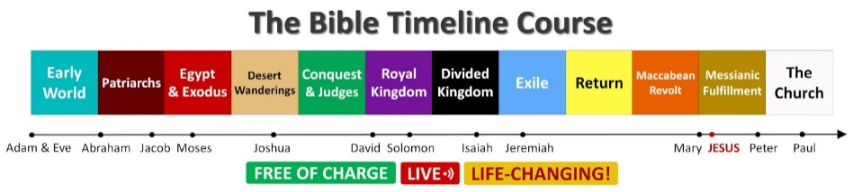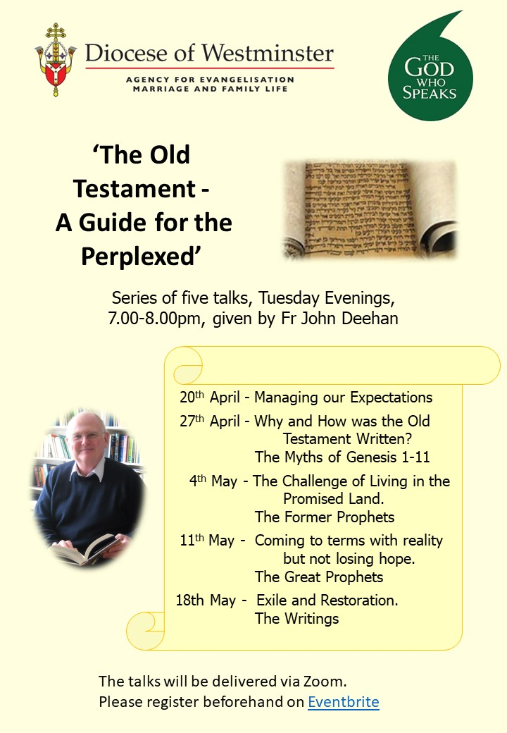

Understand the Bible from start to finish, the Old and New

Testament, with this **FREE OF CHARGE**, worldwide-famous

course delivered online LIVE by Mauro Iannicelli.

Starts on **Wed 7th April 2021** at 7pm UK time

(x8 Wednesday evening sessions).

Info & Registration:[comeandsee.org](http://comeandsee.org)

**Year of St Joseph**

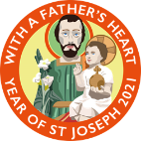‘ Joseph – who stands at the crossroads between

the Old and New Testaments.’ *Patris Corde*

An online talk by Fr John Hemer MHM

**Thursday 29th April,**

7.00pm – 8.00pm

The talk will be delivered via Zoom.

Please register beforehand at [catadmin@rcdow.org.uk](mailto:catadmin@rcdow.org.uk)

To register for Fr John Deehan’s talks go to: [Eventbrite](https://www.eventbrite.com/e/the-old-testament-a-guide-for-the-perplexed-fr-john-deehan-series-tickets-147585890371)

For information on all courses and meetings organised by the Agency for Evangelisation and other diocesan departments, go to <https://rcdow.org.uk/events/>