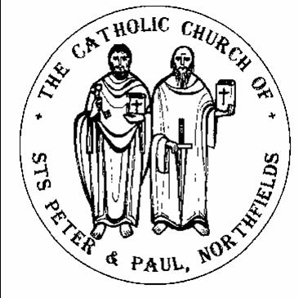
Catholic Church of Sts. Peter and Paul, Northfields
38, Camborne Avenue, Ealing, London, W13 9QZ. Tel. 020 8567 5421
e-mail: northfields@rcdow.org.uk; website: http://parish.rcdow.org.uk/northfields
Facebook page: https://fb.me\38camborneavenue
Parish Priest: Fr. Jim Duffy; Parish Deacon Rev Andrew Goodall
Pastoral Assistant: Anna Maria Dupelycz; Parish Administrator: Rosa Bambury
Alternative Number: 07787 048144 (Anna); northfieldscat@rcdow.org.uk

Office Opening Hours: 10.30am to 2.30pm Monday, Tuesday, Wednesday and Friday.

Sacraments and Devotions:
Sacraments: on enquiry; devotions: Rosary after morning weekday Mass.

In case you are admitted to hospital........
In light of data protection please indicate on entering hospital that your details are to be passed to the RC Chaplain. Also state that you would like the RC Chaplain to visit you.
Psalter week 1
__________________________________________________________________________________________________
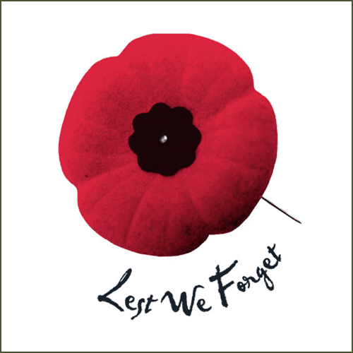
33rd Sunday in Ordinary time Year C (Remembrance)
Sunday 13th November 2022
__________________________________________________________________________________________________
Readings for This Week (33rd Sunday Year C) Malachi 3:19-20, Ps 97:5-9, Thessalonians 3:7-12, Luke 21:5-19
Readings for Next Week (Christ the King Year C) Samuel 5:1-3, Ps 121:1-5, Colossians 1:12-20, Luke 23:35-43
___________________________________________________________________________________

Reflection from Fr. Hilary: “It’s All the Fault of Religion”

So say lots of people. Not just because of the atrocity of 11 September in America and 7 July in London but many other terrible situations. I’m not being uncharitable, only truthful, when I say they are talking ignorantly. It’s the utter distortion of religion which has done so much damage down the years – the appalling irreligious behaviour of many, not religion as such. What gets me too is that people who purport to be very intelligent, a cut above the rest of us, often come out with such erroneous statements. And then they proceed to the next error|: if there were no religions, therefore, the world would be fine. Hoe naive! In his song ‘Imagine’, John Lennon thinks naively that it would be a lovely, happy world if there were no hell or heaven, ‘and no religion too’. As if weak, sinful human nature left to itself would attain greatness of nobility of thought and behaviour. The truth is that without the existence of genuine religion, things would be so much worse.

I’m the first to admit that far too often many people professing a religion have behaved abominably, thereby giving it a bad name. The fanatical and frightening behaviour of a relatively small number of Muslims is indeed reprehensible and sickening but that mustn’t blind us to the sincerity and goodness of the vast majority. Islam has high principles and has produced its own crop of saintly people and deeply spiritual mystics known as Sufis. But Sharia Law and the appalling treatment of women in places like Iran and Saudi Arabia must not be tolerated. In Christian history too, we have had our share of fanatics and people behaving appallingly. But what is often overlooked is the magnificent effect which the exercise of genuine religion has had on countless people. Where individuals or societies have taken on the real thing, it has led to sublime quality thinking and living, a beauty of character to be envied, a self-sacrificing love willing to give its all – in a word, the development of a holiness of life so Godlike in its attraction and dignity. The great religions of the world are an essential part of solving what is wrong. Their mutual cooperation now, is crucial on the things that really matter. Let’s pray like mad for this and be ready to do our bit gladly by reaching out. Genuine religion, then, is not the problem – it’s the only worthwhile solution.

Please keep for prayerful reflection
__________________________________________________________________________________________________

November Dead List Lists and envelopes available from the back of the church.. Please return completed lists to the box provided. For November Masses for the dead, see the poster giving details.

Liturgical Ministries:
a) Altar Servers New recruits required. Anyone eligible who has celebrated First Communion. Please contact Deacon Andrew (andrewgoodall@rcdow.org.uk) Training session Tuesday 22nd November .
b) Music in Mass : Rehearsals as follows: For 11.30am: Weds and for 10.00am Thurs., both rehearsals begin at 7.30pm in the church. Entrance on Wednesdays, via the parish office on Felton Road. New musicians and singers of all ages always welcome to join.
c) Readers and Eucharistic Ministers We need to increase the numbers exercising these ministries. For more information or to express an interest, please contact Anna or Deacon Andrew. (This includes young readers i.e. Post-First Communion upwards.) Next reader training session: Mon 21st , 6.30pm in the church.

Nursery, Reception and Sixth Form Applications Fr Jim will be available to sign forms Monday 14th, Wednesday 16th and Friday 18th November between 5-7pm. This week will be the last opportunity until after Christmas. Should you require copy baptism certificates, please e-mail Rosa at northfields@rcdow.org.uk with name of child, date of birth and approximate date of baptism

Masses this week

Sunday 13th November (33rd Sunday Year C) Thursday 17th November (St Hilda; St Hugh of Lincoln;
(Sat.) 6.00pm Brian Jones (Ann.) No Mass St Elizabeth of Hungary)
8.30am Falbert Ahti (Ann.)
10.00am John (Janusz) Zielinski (1st Ann.) Friday 18th November (Dedication of Basilicas of St Peter & St Paul)
11.30am Denis Daly (Ann.) 9.30am Private Int
6.00pm Nora Dunne (Ann.)
Saturday 19th November
Monday 14th November No Morning Mass
9.30am Carlos Ocaňa (LD.)
Sunday 20th November (Christ the King Year C)
Tuesday 15th November (St Albert the Great) (Sat) 6.00pm Arlene Chandiram (Ann.)
6.00pm All deceased in the last 12 months 8.30am William O’Neil (Ann.)
10.00am Santana Demellor and Demellor family (Ann.)
Wednesday 16th November (St Edmund of Abingdon) 11.30am Knights of St Colomba
9.30am Marie Clerkin (Special Int.) 6.00pm Eddie Walshe (Ann.)

Prayers for the Sick We pray for those suffering from illness and their carers: Annie Bambury (Snr), Elizabeth Gowans, Aimi McEwan, Doreen Foley, Vera Zunzic, Anna Keane, Barbara Lennon Snr, Teresa Hartnett, Stephania Pullin, Geraldine Davison, Dave Mortby, Cerys Edwards, Andrew Chandiram,, Kathleen Walsh, Donna O’Hagan, Ann Hagan, Alan Worman. Sankar Ghosh, Margaret Adu, Therese Biks, Shantha Kumari, Sagundala Devi, Victor Young, Ernst Barroclough, Kathleen O’Donoghue, John Paul Tobin, Our Lady, help of the Sick, pray for us.

Prayers for those Recently Deceased and Anniversaries We pray for repose of the souls of Mary Connell, Josephine Dunne, Carlos Ocaňa and all those whose anniversaries occur around this time, including, Brian Jones, Falbert Ah-Tl, John Zielinski, Denis Daly, Nora Dunne Arlene Chandiram, William O’Neil and Eddie Walshe. May their souls and the souls of all the faithful departed through the mercy of God rest in peace. Amen

Catechetics (Sacramental Preparation) Contact Anna initially on or 07787 048144 with enquiries and queries. Please include a mobile/phone number with your e-mail enquiry.

Infant Baptism Participation in a short preparation course is required before celebrating the sacrament. For more information, please contact Anna preferably by e-mail initially.

Children’s Liturgy of the Word during 10am Mass, term time. Liturgy is aimed at children aged 3 -7 (Nursery to Year 2). We currently have sufficient leaders but more helpers are needed for this ministry to run safely and in accord with Safeguarding guidelines. Please contact Anna as soon as possible. DBS checks processed by the diocese are required for this role. For more information, contact Anna.

First Reconciliation and Communion 2023 The next children’s session for both groups takes place Weds. 23rd November, 6.00pm for 6.15pm start, in the church. Parents’ meeting Monday 14th, 6.30pm, in the church.

Confirmation 2023 Next session will be for ‘Gifts’ group, today, 4.00pm to 5.30pm, Parish Hall. Anyone older than Year 11 (age16), wishing to be confirmed, please contact Anna to discuss possibilities.

Thinking of Becoming Catholic? Or would like to know more about the Catholic faith? For more information on how to go about this, please contact Anna to arrange an informal chat in the first instance.

Getting Married? Please note that at least 6 months’ notice is required wherever your marriage is taking place. For further initial information, please go to: https://parish.rcdow.org.uk/northfields/sacramental-prep/marriage-preparation/

Parent and Toddler Group Wednesdays (term time) from 9.30am to 11am, in the Parish Hall, more volunteers needed to help run the group. Please contact Rosa or Anna in the parish office.

Host Family Sought: we are looking to pass the baton on to another local family willing to host a lovely mother and her two children, boy 10 and girl 3 under the Homes for Ukraine scheme. They are currently living with us in Northfields are looking for a new home for December. Please contact Claire 07932715084 for more details.

Sustainable Flower Workshop Sat. 19th Nov, 10.45am to 1pm, Parish Hall. Come and learn what materials can be used in flower arrangements that are environmentally friendly. Please leave name and contact details with the parish office by the end of this weekend.

Second Sunday’ Monthly Coffee mornings Sunday 13th November from 9-11.30 am. All welcome to the church hall for bacon sandwiches, tea, coffee and cake and craft for the children after 8.30 Mass, after 10am and before 11.30 Mass. There’ll also be a raffle in aid of Acton and Hanwell Homeless Concern with some great prizes to be won! Please contact Jonny.sullens@futurenet.com if you would like to help by making a cake or helping to serve for an hour. We look forward to meeting up as the church community again!

Date for your diary….The parish carol service will take place on Friday 16th December, 7.30pm – 8.30pm, in the church, followed by mince pies and mulled wine or punch in the parish hall. More details next week.

“Witness to Hope: The Prayers and Readings of Advent” A series of 4 online talks given by Fr John Deehan. 17th & 24th November, 1st & 8th December. To register: Please click on this link Eventbrite
(https://www.eventbrite.co.uk/e/witness-to-hope-the-prayers-and-readings-for-the-sundays-of-advent-tickets-429217229287 )
For information or queries, contact Anna, annadupelycz@rcdow.org.uk

Safeguarding The Parish reps are Susie Worthington, and Tracy Paterson northfieldssg1@safeguardrcdow.org.uk

