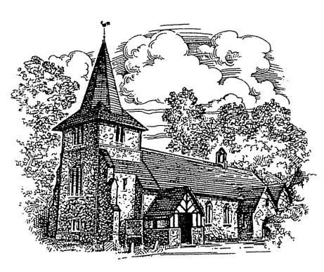
5 PARK ROAD
RICKMANSWORTH
OUR LADY HELP OF CHRISTIANS OUR LADY HELP OF CHRISTIANS
RICKMANSWORTH

5

CATHOLIC CHURCH
5 PARK ROAD
RICKMANSWORTH
Parish Priest: Fr Shaun Church Assistant Priest: Fr Mark Walker
Parish Administrator: Mrs Kerry Van Rensburg

19TH SUNDAY IN ORDINARY TIME - 10th AUGUST 2014

Entrance Antiphon: | Look to your covenant, O Lord, and forget not the life of your poor ones for ever. Arise, O God, and defend your cause, and forget not the cries of those who seek you.
1st Reading: | 1 Kings 19:9. 11-13
Response to Psalm: | Let us see, O Lord, your mercy and give us your saving help.
2nd Reading: | Romans 9:1-5
Gospel: | Matthew 14:22-33
Communion Antiphon: | O Jerusalem, glorify the Lord, who gives you your fill of finest wheat.

Mass Intentions
SUNDAY  8.30 AM  11.00 AM  6.00 PM | For the People of the Parish  Mary Robinson RIP  John David Thomson RIP
MONDAY 9.30 AM | Mary Fenton RIP (Anniv.)
TUESDAY 9.30 AM | For the Sick and Housebound of the Parish
WEDNESDAY 11.00 AM | FUNERAL - NORAH LOADER RIP
THURSDAY 9.30 AM | Fr Michael Archer RIP
FRIDAY  9.30 AM  7.00 PM | Catherine and Leo Gaughan RIP (Anniv.)  Anthony Holmes RIP
SATURDAY | No Mass here today

