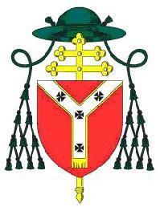 | St. Aloysius Roman Catholic Parish, Somers Town  20 Phoenix Road, London, NW1 1TA  Tel: 020 7387 1971 Email: somerstown@rcdow.org.uk

APPLICATION FORM FOR INFANT BAPTISM
PLEASE WRITE IN BLOCK CAPTITALS

Child’s Surname _________________________ Child’s Christian name(s) ______________________
Child’s Date of Birth ____/ ____ / ____ Male / Female

Address ________________________________ Telephone _________________________________

_______________________________________ Mobile ____________________________________

_______________________________________ Email Address _______________________________

Postcode _______________________________

Father’s Name(s) __________________________________________

Is the Father a baptised Catholic? Yes / No

Mother’s Name(s) __________________________________________

Mother’s Maiden Name __________________________________________

Is the Mother a baptised Catholic? Yes / No

Are the parents married? Yes / No

Were you married in a Catholic Church Registry Office Another Church

Name of Godfather(s) ___________________________________________

Name of Godmother(s) ___________________________________________

Please Note that one of the Godparents must be a practicing Roman Catholic and that parents/guardians of Children under 7 will be asked to attend two baptism preparation evenings before their child is baptised. Please circle which set of sessions you will be attending.

Baptisms usually take place on a Saturday. Please do not commit to a party venue before the date for your baptism has been confirmed. Children aged 7 or above will usually be expected to participate in the parish’s communion programme.

Parent / Guardian Commitment In asking to have our child to be baptised in the Catholic Church, we are agreeing to bring up our child in the knowledge and practice of the Catholic Faith.

Signed __________________________ (Mother) _____________________________ (Father)

