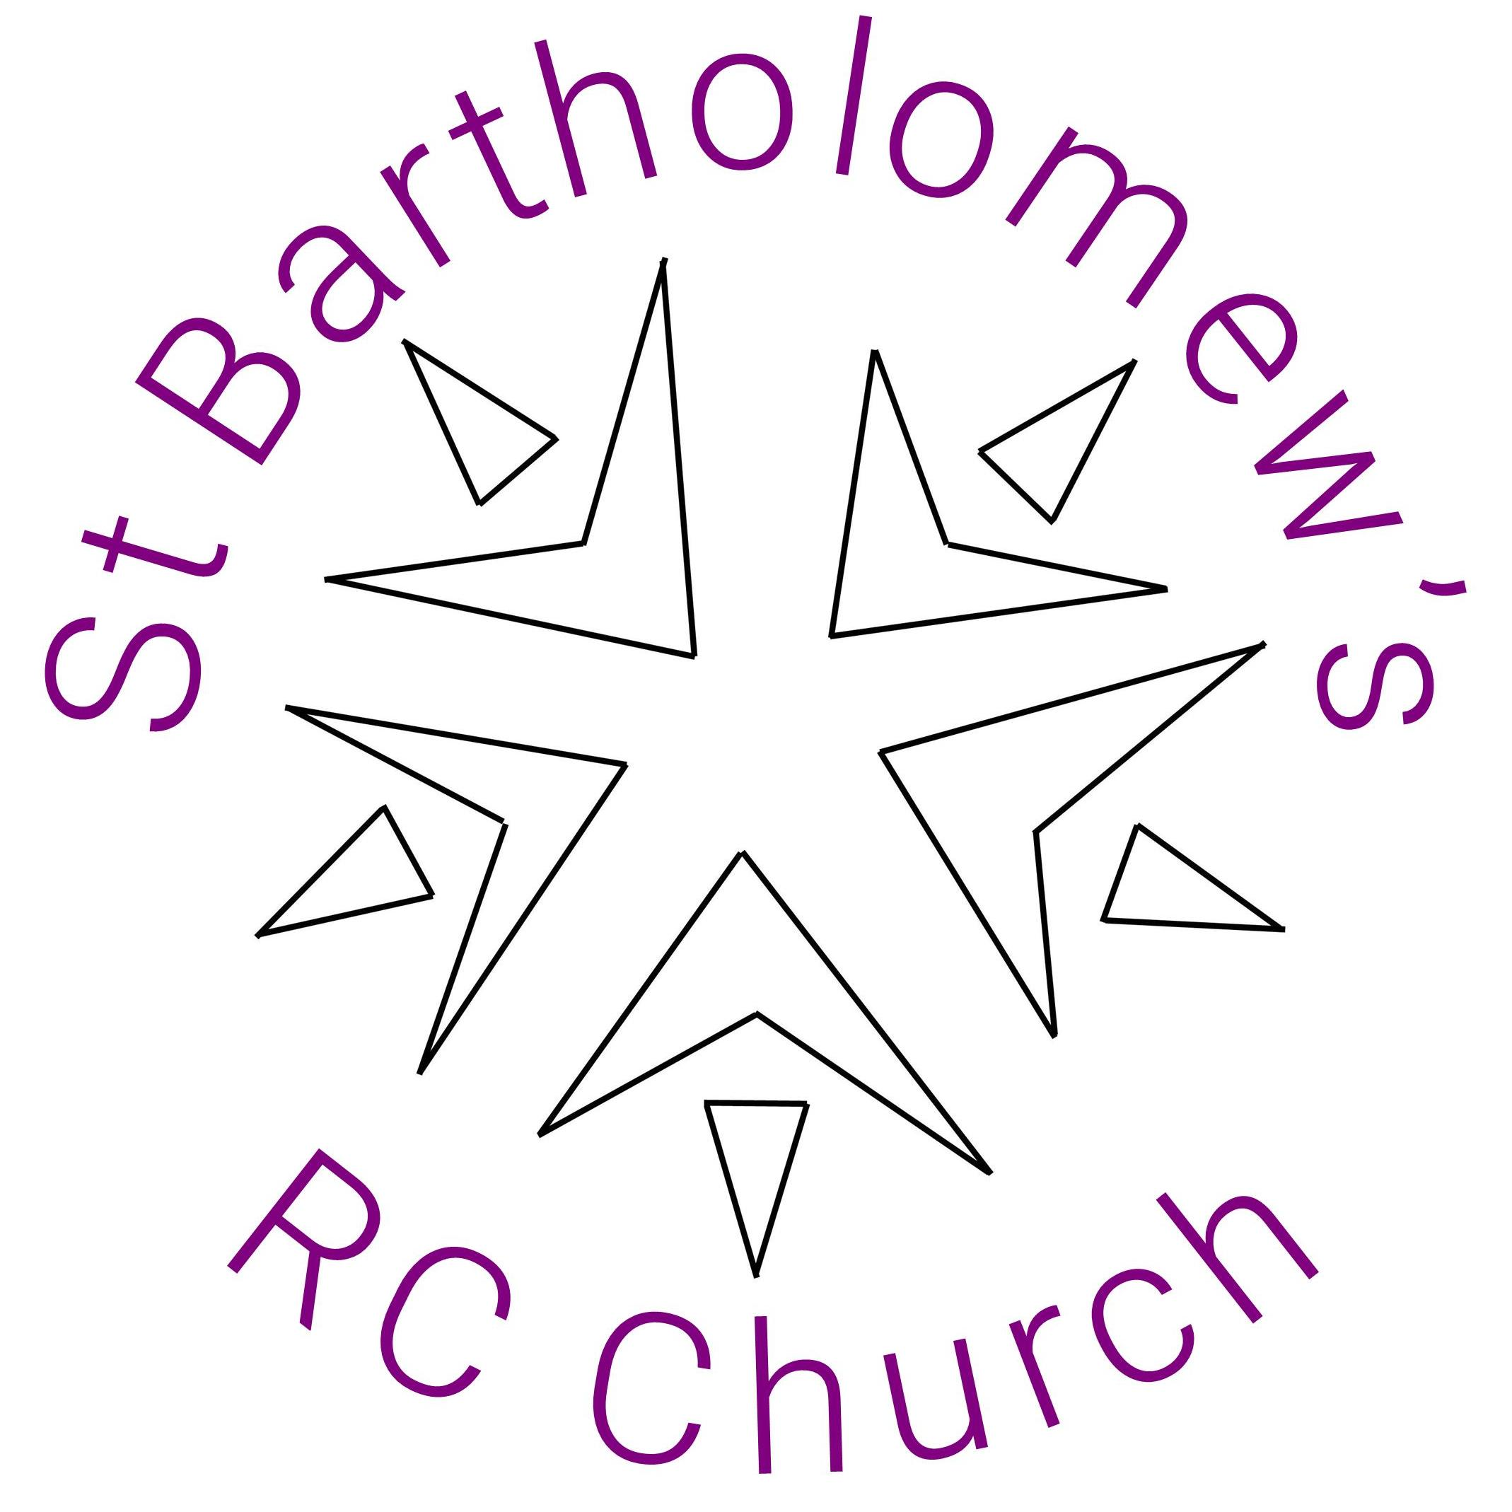
2023 PARISH COUNCIL
PLANNED EVENTS
January | February | March | April | May | June | July | August | September | October | November | December
Christian Unity Week  8-25 January  (Ecumenism) | Cakebake  12 February  (Building Community) | Lent Family Fast Day  3 March  (Social Justice and Spirituality) | Easter  7 - 9 April | Pentecost  28 May  updated Welcome Guide and  Update on Evangelisation | Plant Tree for South S Albans Churches in Community Garden in Greenwood Park 2.30 pm on Sat 3 June  Alban Pilgrimage  24 June  (Ecumenism) |  | Cakebake  13 August  Weekend of the Assumption  (Building Community) |  | 7 October  Auction  Parish Heating Fundraising & Social event | 4 November  Weekly Memorial Candles start  10 Nov – Bingo at St Albans & St Stephens  Fundraising and social  14 November  Candlelight Service of Remembrance & Reflection on the Afterlife | 2 December  Retreat – the Meaning of Advent  Advent  (Spirituality)  9 December  Festive Fair  10.45-3 pm
Pilgrimage style visit to St Albans Cathedral  10 January  (Spirituality) | Children’s focus Mass  12 February 10:30am Mass  (Youth) | Fairtrade Lunch  12 March  (Social Justice) | Good Friday Walk of Witness  7 April  (Ecumenism) | The Rosary  Throughout May In liaison with CWL  (Spirituality) | CTSA Summer Forum: What Youth think  27 June  (Ecumenism & Youth) |  | St Bartholomew  Novena  (Spirituality) | 10 Sept  Fairtrade Lunch/ Parish Get Together |  | Advent Groups  20 Nov (4 wks)  (Ecumenical)
Christian Unity Week Candle Exchange  22 January 10.30am Mass (Ecumenism) | Update the Welcome Guide  By the end of February  (Building Community) | Pilgrimage to Walsingham 25 March, the Feast of the Annunciation.  Coach from St Bart's | Unity at the Cross  7 April  (Ecumenism) |  |  |  |  |  | Creationtide  Prayer Walk  (Ecumenical)
Adopt a Plant
April
(Ecumenism)
Children’s Liturgy: Ruth Newman and Sinead Hughes continue to lead the embedding of the returned Children’s Liturgy. Continues throughout the year.
Asylum Seekers: Meet each Thursday morning from 10am – 12am in the church hall for English conversation. The support group also give out bikes at the hotel, arrange bike training and try to find solicitors. Continues throughout the year.
And lots more: There are many additional events taking place over the course of the year such as Bart's annual HCPT Pilgrimage after Easter as well as Quiz evenings, Golf Day, Jumble Sales alongside Newman Society events.
Keep an eye on the weekly newsletter for the latest information on all the upcoming events, activities, and parish community groups.

