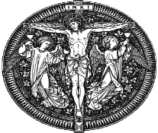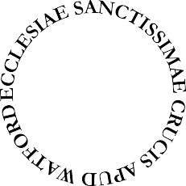
FIRST HOLY COMMUNION
Application Form

If your child is in Year 3 or older your child may apply to join our First Holy Communion Programme. The deadline for applications is THE END OF OCTOBER We cannot accept applications after this date
CHILD’S DETAILS
Child’s Full Name |  | BOY / GIRL
Last | First | Please circle
Date of Birth | Date of Baptism
 |  | Month and Year
Place of Baptism
Church
Full Address (including Country) | Children baptised at Holy Rood do not need a certificate as we have a record of the baptism
Please obtain a certificate of Holy Baptism from all other churches and attach to this form.
School Details
Name of School |  | School Year
Allergies or Special Needs
PARENT’S DETAILS
Family Address
House Number/Flat Number, Street and Town |  | Post Code
Mother’s Name
Father’s Name
Contact Details
Telephone | Mobile | Email Address (Please write clearly)
Which church does your family usually attend on Sunday for Mass and at what time ?

Protecting your privacy
Your personal details will be held on file/stored on the parish computer securely. After the First Communion programme, your details will be entered into the First Communion Register. You can read our full privacy policy on rcdow.org.uk/
diocese/privacy-policy
For official use only
Date application received Donation Received 

Please note there is a recommendation donation of £30 cash or cheque made payable to
‘Holy Rood Watford’
which will be collected at the beginning of the programme.

Dates will be published in the newsletter.

