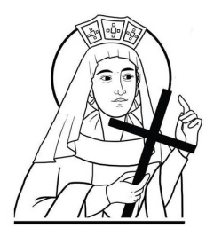
St Helen’s ChuRCH
The Harebreaks
Watford WD24 6NJ
01923 223175
watfordnorth@rcdow.org.uk

RITE OF ELECTION FOR THE SACRAMENTS

Catechumens & Candidates

Surname |  | 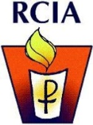
Forenames (Baptismal)
Date of Birth
Place of Birth
Father’s Full Name
Mother’s Full Name
Mother’s Maiden Name
(if applicable)
Date of Baptism
Place of Baptism
Name of Minister/Priest
Godmother’s Name
Godfather’s Name
Date of Confirmation
Confirmation Name
Name of Sponsor
Your Address
Town
Postcode
Phone Number
Email Address

_________________________________________________________________________

