Planned Programme Dates:
Thursday 19th January 6pm to 7pm at Church - Introduction to the programme, dates, meet the Catechists, introduction to I Belong book.
Thursday 26th January 6pm to 7pm Zoom Chapter 1 – Story of Jesus Baptism video https://www.youtube.com/watch?v=_VMNO2MAmwA
Chapter 2 - Penitential Rite, story of Prodigal Son Video (74) LEGO - The Prodigal Son - YouTube
Thursday 2nd February 6pm to 7pm Zoom Chapter 5 - Glory to God
Moses and the Burning Bush https://www.youtube.com/watch?v=QdxJLTWkv5A&t=21s
Gloria & link to Christmas story & angels greeting the shepherds with good news. Hymn the Clapping Gloria https://www.youtube.com/watch?v=U0SrN4B-HTU
Chapter 6 - Word of the Lord Samuel’s Call. Video https://www.youtube.com/watch?v=Ewa8OwQtVwU
Mass readings OT, Responsorial Psalm, NT, Gospel & responses.
Thursday 9th February 6pm to 7pm Zoom Chapter 7- Bread to offer – preparation for the Eucharist Feeding of the 5000. Video https://www.youtube.com/watch?v=S6rj9cAJrWE Offertory gifts and preparation. Making bread at home…love to see photos of the bread!
Chapter 8 - Fruit of the wine – wedding feast at Cana. Video https://www.youtube.com/watch?v=S6rj9cAJrWE Celebrations. Remembering Past & Present, & planning for the Communion Day
Thursday 16th February – Half Term Week
22nd February - Ash Wednesday
Thursday 23rd February - Practical Session in Church The tour and discuss entry to the Church, various rituals, the Sign of the Cross, preparation for the Mass/Eucharist.
Thursday 2nd March 6pm to 7pm Zoom
Chapter 9 - The Last Supper & preparation for the Eucharist, Passover video https://www.youtube.com/watch?v=1IwMt-KLkSE Lamb of God & Sign of Peace
Chapter 10 - Body of Christ – Story of Risen Lord & story of Mary in the garden video https://www.youtube.com/watch?v=UtSfON2qHEc
Eucharist preparation, Consecration & receiving the Body of Christ at Communion
Thursday 9th March 6pm to 7pm Zoom Chapter 11- Go in peace to love and serve the Lord To love & to serve looking at different ways to serve in community – offering to help and to be a good friend & neighbour. Letter of thanks to Parents & God parents. Prayers P129
Thursday 16th March Reconciliation Preparation 6pm to 7pm Zoom Chapter 3 - Rescue story of Daniel video https://www.youtube.com/watch?v=bEM_X25DWPk
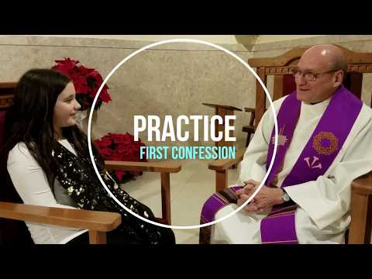
Chapter 4- Zacchaeus video https://www.youtube.com/watch?v=5Bjt bJFz2ug
Act of Sorrow or Contrition O my God, I am sorry for what I have done wrong,
I know you love me, and I want to love you too.
With your help I will try not to sin again. Amen
First Confession Guide
Penitential Service for Children – Order of Service to upload
Thursday 23rd and 30th March 6pm to 7pm Practical Sessions in Church
Easter Holidays 3rd April to 14th April 7th April Good Friday – Children Stations of the Cross 9th April Easter Sunday
Thursday 20th & 27th April 6pm -The Sacrament of First Reconciliation with children in the church
Check books have been completed
First Holy Communion Masses
Saturday 13th May - Rehearsal on Thursday 11th May
Saturday 20th May- Rehearsal on Wednesday 17th May (Thursday 18th May - Ascension of the Lord)
