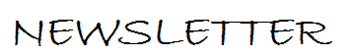
The Parish Office is closed to the public, please contact by email as above.
Suspension of Public Services
As earlier in the year, the Government has suspended public worship in our churches. This time round we have at least the ability to live stream the Masses which will be said in church, but without a congregation.
Although the legislation allows for churches to be open for private prayer, we have found recently a challenge in getting regular stewards to cover the times of opening – and for quite a small number of people coming to pray – as well as the effort and expense of de-sanitizing the church after each session.
Since we have now the live streaming option the church will be closed, except for private prayer on Saturday and Sunday from 10am – 12 noon.
To access this go online to:-
https://www.churchservices.tv/whetstone
& click on the play button.
Offers to be in church as a steward for half an hour, Saturday and Sunday 10.00 – 10.30am, 10.30 – 11am, 11 – 11.30am and 11.30 – 12 noon would be much appreciated. Please email the parish office.
November – Month of the Holy Souls
Masses and prayers are said in this coming month for the faithful departed.
Church Website is at present inaccessible. It is hoped to get this up and running very soon to keep people informed of future developments, regularity of services etc. In the meantime information can be found via the Diocesan website:-
https://parish.rcdow.org.uk/whetstone

Mass times

Sunday: 9.30am
Weekdays:
Mass 9.30am
Opening times for Private Prayer:
Saturday and Sunday
10am – 12 Noon



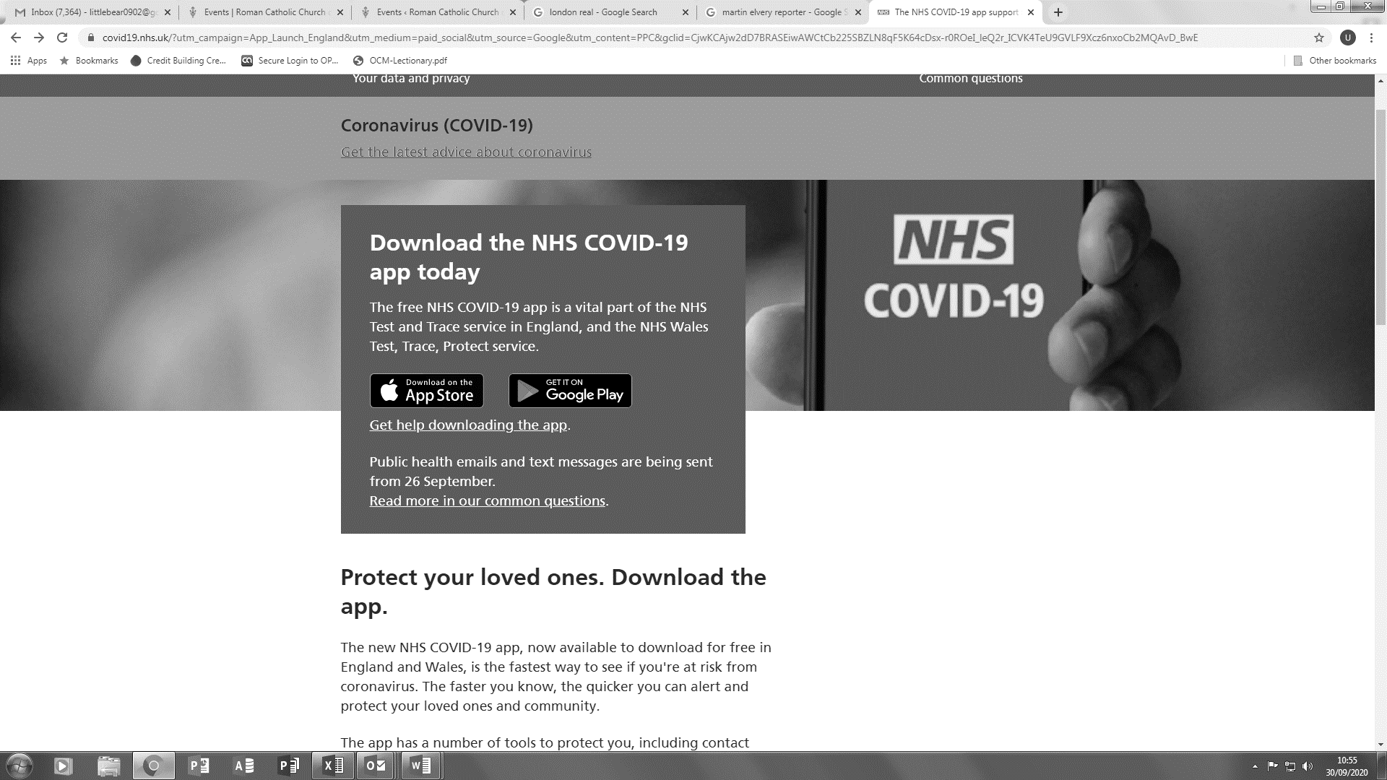
Parish Finances
Again, as in the Spring, we are faced with a period when there will be no Sunday collections. This is having a considerable impact on the parish finances. Work has recently finished on the Hall kitchen etc, which was planned and began before the first lockdown. The bills for that have had to be honoured and paid (£50,000). We have been grateful to all those who have contributed during this period by Bankers Orders, and also those who have handed in contributions for the Sunday’s missed.
In these unsettling times, the method of giving to the parish is invaluable and reassuring. You will find attached to this newsletter a form to set up such Standing Order if you are able and bless you if you can.
Light in the Gloom
One piece of good news. Congratulations to England Rugby Team the winners of the 2020 6 Nations Rugby Cup – and to Maro Itoje who played in the final. Maro and his brother Jeremy moved into the parish earlier this year. Good to have them among us.
Mass Intentions
Please note that the new diary is now open for requests for Masses in 2021, but we reserve the right for pastoral reasons to move any Mass booked. Please leave requests and stipends in the Presbytery letter box.
Preparation for the Sacraments in 2021
Although it is early days yet, names are being taken for those interested in being prepared for First Confession, First Holy Communion and Confirmation in 2021. Please contact Winnie Brady at winniebrady@rcdow.org.uk if you wish to receive an Enrolment Form for these courses.
Children’s Liturgy – a note for parents of young children
Due to the current situation it isn’t possible to celebrate Children’s Liturgy at Sunday Masses; however, it is possible for you as parents to find materials and celebrations on the Internet. Take a look at the CAFOD website https://cafod.org.uk/Education/Children-s-liturgy where you will find prayers and resources for families who aren't able to attend church in person at the moment. It is possible to join the Virtual children's liturgy by subscribing online.
Sunday Liturgy worksheets may be found at www.sdc.me.uk/sundayliturgy7
In addition, a full Children’s Liturgy at https://rcdow.org.uk/faith/catechesis/childrens-liturgy which is used as the basis for our parish Children’s liturgies.
These are but a few of the many resources to be found online – mostly pitched at toddler – junior school ages. Do take a look and explore what is on offer for your child’s Faith formation.

Boxing Club Suspended until
Mother’s Prayers further notice

Children’s Corner
The Bible Timeline Course is a free 7-session online course starting on Wednesday, 4th November at 7pm Live streamed – free of charge interactive course.
Grasp the Big Picture of the Bible from Old Testament through to New Testament.
Details and Register at www.comeandsee.org
Pay Car Park
Free Parking for Mass goers is:- Saturday 5.30pm-7.30pm and on Sunday 8.30am-5.30pm.

Please be aware that outside of these times, a penalty will be issued – and no appeal through the parish under the terms of the contract.
Holy Days of Obligation during the week are not included except Christmas and Good Friday.
Hospital Admissions often the religious status of a person admitted to hospital is overlooked on admission. Please make sure that Chase Farm & Barnet hospital is told that the patient is a Catholic.
As there is at present no Chaplain. Please inform the staff nurse on the ward a patient is Catholic. Soon we hope a new Chaplain will be appointed.
PRAY for those who are sick. We also pray for our long-term sick, the housebound, and those in residential care and in local hospices and hospitals and the Faithful Departed Fr John Miller.

O God, the Creator and Redeemer of all the faithful; grant to the souls of Thy servants departed the remission of all their sins, that by pious supplications they may obtain pardon which they have always desired. Who livest and reignest, world without end. Amen.

