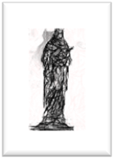
PARISH NEWSLETTER
8th MAY
2022.
FOURTH SUNDAY OF EASTER/
JESUS, GOOD SHEPHERD

SHRINE & PARISH OF OUR LADY OF WILLESDEN,
1, NICOLL RD, LONDON, NW10 9AX.
Tel: 0208 965 4935 email: willesden@rcdow.org.uk/
Website https://parish.rcdow.org.uk/willesden
Rector and Parish Priest: Fr Stephen Willis.
Assistant Priest: Fr Jonathan Stogdon.
Parish Secretary: Karen Toole.
Office hours: Tuesday-Friday 10.30am-12.30pm

MASS TIMES:
Saturday 6pm (Anticipated Mass for Sunday)
SUNDAY 9am (simple said)
11am (Solemn Mass with Choir)
5.30pm (Traditional Latin Low Mass)
DAILY: Mon to Saturday 10am,
Monday to Friday 7pm (not Bank Holidays)
Confessions: Tue 5.15-5.45pm & Sat.10.30-11.30am & 5-5.45pm.
Masses & Sanctuary Lamp intentions this week.
Sacred Heart Lamp – Victims of war in Ukraine
Blessed Sacrament Lamp 1 - Theresa Walls- Int.
Blessed Sacrament Lamp 2 -Angelina De Almeida- Int.
Shrine Lamp – Peace in Ukraine
Mass intentions from Saturday 7th May 2022
6pm: Emelia Sylvan –Lately Dead
Sunday 9am: Michael Norris Levine -Anniversary
11am: Brian Marshman – Lately Dead
5.30pm: Maria Rosa Mendoza – Anniversary
Mon: 10am: Vincia Christmas –Lately Dead
7pm: Ann Heaney – Lately Dead
Tues: 9am: November Dead List 2021
7pm: Tom Fahy – Intention
Wed: 10am: Bridget King – Lately Dead
7pm: Cleris Schmidt – Anniversary
Thursday: 9.45am : Eulogy
10am: Funeral Mass Norma Alfred RIP
7pm: Grace Tinini Ochola – Intention
Fri: 10am: Cecilia Byrne- Int.
7pm: Rose Marie Barrett - RIP
Sat: 10am: Elsie O’Connell – Sick Int.
6pm: Deceased Members & friends of the Victor & Cakuiji Family – Int.
Sunday 9am: Vincia Christmas –Lately Dead
11am: Catherine Harkin- Anniversary
5.30pm: Pro Populo
Masses & Sanctuary Lamp intentions can be booked online: willesden@rcdow.org.uk or by phone 02089654935. MASS INTENTIONS ARE AVAILABLE FROM 7th June and Lamps from next weekend!

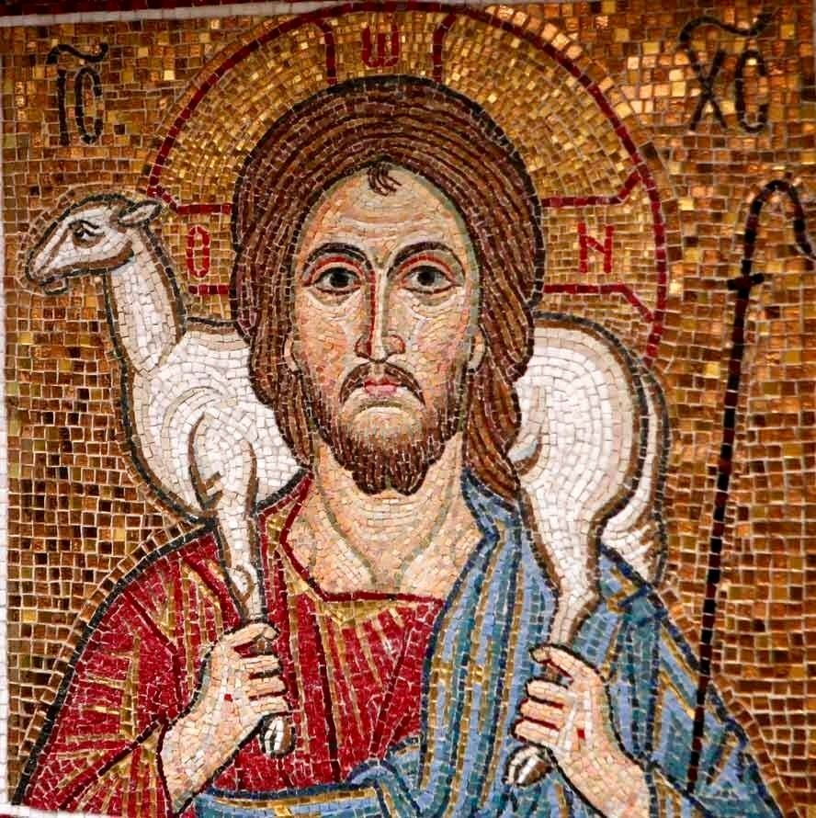

God used the image of a shepherd to describe his covenant relationship and care for his chosen people who were called by his name (Psalm 80:1 and 100:3). God called David, who shepherded his father's flock in his youth, to be the anointed king and shepherd for his people Israel (Ezekiel 37:24). Jesus, God's anointed Messiah and King, born from the tribe of David, called himself the Good Shepherd of the people whom his Father had entrusted to his care (John 10:29).
Peter the Apostle tells us that the Lord Jesus is the Good Shepherd and Guardian of our souls (1 Peter 2:25). He keeps a close and personal watch over every one of his sheep - his followers (disciples) who belong to him. He calls each of us personally by name to follow him. And he promises to be our guardian and protector from the snares of our enemy, Satan, the father of lies and a murderer from the beginning (John 8:44). The Lord leads us each day to good pastures - places where we can feed on his word and drink from the well-springs of living water which is his Holy Spirit (John 7:38-39, John 4:14). If we feed on his word and drink from the living water of the Holy Spirit, we will find the nourishment and strength we need to live each day for his glory and honour. Do you recognize the voice of your Shepherd and Guardian who calls to you each day?
Lord Jesus, you have the words of eternal life. Open my ears to hear your voice and to follow your ways. Give me understanding that I may grow in the knowledge of your great love and wisdom for my life.
Priest Training Fund On this Good Shepherd Sunday we have a second collection to support the Priest Training Fund. This fund pays for the priestly formation of men for the Catholic priesthood. There are currently 58 men studying at Allen Hall seminary, 17 of whom are from our own Diocese, and two men are studying in Rome, also from our Diocese. Last year four men who studied at Allen Hall were ordained to the priesthood to serve as our in our diocese. The fund also supports the ongoing enrichment and formation of our ordained priests. Your gift ensures we can provide training for these men responding to Christ’s call to dedicate their lives to serve God’s people. Please be as generous as you can. Please also pray for vocations and for all our priests. If you do not have a donation envelope, plenty are still available at the back of the church. You can use the QR code to make your donation online or visit www.rcdow.org.uk/donations. Thank you for your generosity.
THIS WEEK:
IN CHURCH:
Mass on Tuesday morning will be celebrated at 9AM. Weekday Rosary: in the Shrine at 10.30am. Exposition of the Blessed Sacrament: Tuesday and Saturday between the morning and evening masses. Shrine Prayers: 7.30pm Tuesdays. Coffee and Bible Study: Thursdays after the 10am Mass.
Legion of Mary: Sundays, 12.30pm – 2pm in the Presbytery Church Cleaning: Wed 8.30am-10am. Ghanaian Community: First Sundays in the Hall at 12.30pm. (TODAY!) ONLINE: Children’s Liturgy: https://youtu.be/TA4B_qCb9S0 (KS2), or https://youtu.be/Ju9YmEMUBJc for Early Years/KS1
Mass: https://parish.rcdow.org.uk/willesden or the Willesden Shrine-RC Church Facebook Page. Weekday mass this week : Monday 10am & Tuesday 9am, and 9am on Sundays. Sign up for e-Alerts from the Parish to receive news, updates and the weekly Newsletter directly to your email! Go to the parish website: https://parish.rcdow.org.uk/willesden
First Holy Communion Programme: First Confessions from 10.30am next Saturday Parish Funerals:
Norma Alfred RIP- Funeral Mass -Thursday 12th May: 9.45am Eulogy, 10am Requiem Mass followed by 11.30am Committal at Willesden New Cemetery. John Richard Daniell RIP – Funeral Mass on Thursday 10am Thursday 19th May followed by Committal at West London Crematorium at 11.30am. We pray for them and all who mourn them.
Lourdes 2022.There will be a Westminster Diocesan Pilgrimage to Lourdes this year, from 22-29 July. Fr Stephen will be going, and any interested parishioners can get a Booking Form from him.
Parish Offerings: Weekend of 1st May: £1,483.30; Shrine Restoration £42.12; Organ Fund: £70.96 Many thanks to all who support us.
SPECIAL THANKS Fr Stephen & Fr Jonathan wish to thank you for your greetings, kindness & gifts at Easter. We will both offer Mass for your intentions.
Good Counsel Network On Saturday 21st May please pray and fast for the end of abortion and euthanasia in this Country. On this month's Day of Prayer and Fasting for Life, we are especially asking you to fast and pray for the end of DIY abortions at home. Please join in and invite others to join as well. www.GoodCounselNetwork.com

MAY PROCESSION TODAY, (Sunday), at 3pm.
Our preacher will be The Ukrainian Eparch in Britain, Bishop Kenneth Novakowski, accompanied by the Pokrova Icon. Please do make every effort to join in the May Procession, the first in 3 years, in Prayer for our City, and also for Peace in Ukraine, and as a sign of our solidarity with our brothers and sisters suffering so much. REMEMBER: If you live on Nicoll Rd, St Mary’s Road, St John’s Avenue, Park Parade, High Street, and the short section of Acton Lane back to Church, place a poster, Holy Picture, statue or Crucifix where we can see it, and we will bless your home as we pass by! Please take a Poster to display.
We need Stewards and bearers of the litter carrying the Processional statue. Please gather by the pulpit by 2.40pm.

