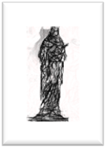
PARISH NEWSLETTER
1ST MAY
2022.

THIRD SUNDAY OF EASTER

SHRINE & PARISH OF OUR LADY OF WILLESDEN,
1, NICOLL RD, LONDON, NW10 9AX.
Tel: 0208 965 4935 email: willesden@rcdow.org.uk/
Website https://parish.rcdow.org.uk/willesden
Rector and Parish Priest: Fr Stephen Willis.
Assistant Priest: Fr Jonathan Stogdon.
Parish Secretary: Karen Toole.
Office hours: Tuesday-Friday 10.30am-12.30pm

MASS TIMES:
Saturday 6pm (Anticipated Mass for Sunday)
SUNDAY 9am (simple said)
11am (Solemn Mass with Choir)
5.30pm (Traditional Latin Low Mass)
DAILY: Mon to Saturday 10am,
Monday to Friday 7pm (not Bank Holidays)
Confessions: Tue 5.15-5.45pm & Sat.10.30-11.30am & 5-5.45pm.
Masses & Sanctuary Lamp intentions this week.
Sacred Heart Lamp – Victims of war in Ukraine
Blessed Sacrament Lamp – Theresa Walls- Int.
Shrine Lamp 1- Maria Cruzinha – Int.
Shrine Lamp 2- Jose & Maria Quadros- Int.
Mass intentions from Saturday 30th April 2022
6pm: Maureen Mashman- Int.
Sunday 9am: John Palmer –Lately Dead
11am: Pro Populo
5.30pm: Micheal O’Beirne – RIP
Mon: 10am:Vinica Christmas -RIP
7pm: No Mass
Tues: 10am: Catherine McAlister – Sick Int.
7pm: Margaret Neylon –Lately Dead
Wed: 10am: Leitao family –Thanksgiving Int.
7pm: Arthur Cardozo – Birthday Int.
Thursday: 10am: Holy Souls OLM
7pm: Tom Fahy – Int.
Fri: 10am: Ellen Tomany – Lately Dead
7pm: Anthony McNamara – Lately Dead
Sat: 10am: John Palmer – Lately Dead
6pm: Emelia Sylvan –Lately Dead
Sunday 9am: Michael Norris Levine -Anniversary
11am: Brian Marshman – Lately Dead
5.30pm: Maria Rosa Mendoza - Anniversary
Masses & Sanctuary Lamp intentions can be booked online: willesden@rcdow.org.uk or by phone 02089654935. MASS INTENTIONS ARE AVAILABLE FROM 7th June and Lamps from next weekend!

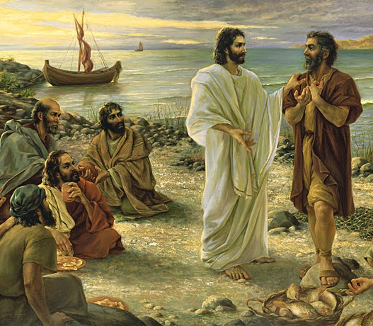

In his third appearance to the apostles, Jesus prepared a breakfast for them and ate with them. Peter's prompt response to draw near to the Lord and eat breakfast with him stands in sharp contrast to his previous denial and distancing himself from his Master during the night of Jesus' arrest and trial. Why did Jesus question Peter's love and loyalty three times in front of the other disciples? It must have caused Peter pain and sorrow since he had publicly denied Jesus three times previously. Now Peter, full of remorse and humility, unequivocally stated that he loved his Lord and Master and was willing to serve him whatever it might cost.
When Jesus asked Peter "do you love me more than these?" he may have pointed to the boats, nets and other fishing companions. He may have challenged Peter to let go of his career as a fisherman for the task of shepherding the people whom Christ would call to be his disciples. Jesus may have also pointed to the other apostles and to Peter's previous boast: "Though they all fall away because of you, I will never fall away" (Matthew 26:33). Peter now makes no boast or comparison but humbly responds: "You know I love you."
Saint Augustine of Hippo (354-430 AD) wrote in his famous confession a remarkable prayer of thanksgiving and love: "Late have I loved you, O Beauty so ancient and so new. Late have I loved you! ...You shone your Self upon me to drive away my blindness. You breathed your fragrance upon me... and in astonishment I drew my breath...now I pant for you! I tasted you, and now I hunger and thirst for you. You touched me! - and I burn to live within your peace." (Confessions 10:27)
Lord Jesus, inflame my heart with your merciful love and remove everything that is unkind, ungrateful, unloving and unholy, and that is not in accord with your will. May I always seek to love you above all else and follow you wherever you wish to lead me.
Priest Training Fund
Next Sunday is Good Shepherd Sunday, the day we pray for priests and for vocations to the priesthood. The annual collection for the Priest Training Fund will take place next weekend. This fund pays for the priestly formation of men for the Catholic priesthood. There are currently 58 men studying at Allen Hall seminary, 17 of whom are from our own Diocese, and two men are studying in Rome, also from our Diocese. Last year four men who studied at Allen Hall were ordained to the priesthood to serve as our future priests. This fund also supports the ongoing enrichment and formation of our ordained priests. Your generous donation helps ensure we can support these men who are called to be like Christ the Good Shepherd. Donation envelopes are available in the back of the church. Please take one home, read the information, and bring it back next weekend with your donation. Please continue to pray for vocations and for our priests. You can use the QR code to make your donation online or visit www.rcdow.org.uk/donations. Thank you for your generosity.

THIS WEEK:
10am Mass only on Bank Holiday Monday (2nd May). After that the normal pattern returns.
Lourdes 2022.There will be a Westminster Diocesan Pilgrimage to Lourdes this year, from 22-29 July. Fr Stephen will be going, and any interested parishioners can get a Booking Form from him.
IN CHURCH: Weekday Rosary: in the Shrine at 10.30am. Exposition of the Blessed Sacrament: Tuesday and Saturday between the morning and evening masses. Shrine Prayers: 7.30pm Tuesdays. Coffee and Bible Study: Thursdays after the 10am Mass. Next meeting is this Thursday 5th May. Legion of Mary: Sundays, 12.30pm – 2pm in the Presbytery Church Cleaning: Wed 8.30am-10am. Ghanaian Community: First Sundays in the Hall at 12.30pm. (TODAY!) ONLINE: Children’s Liturgy: Search on Redemptorists Online.
Mass: https://parish.rcdow.org.uk/willesden or the Willesden Shrine-RC Church Facebook Page. Weekday mass this week (See times above) and 9am on Sundays. Sign up for e-Alerts from the Parish to receive news, updates and the weekly Newsletter directly to your email! Go to the parish website: https://parish.rcdow.org.uk/willesden
Parish Funeral ; Norma Alfred RIP Funeral Mass -Thursday 12th May: 9.45am Eulogy, 10am Requiem Mass followed by 11.30am Committal at Willesden New Cemetery. We pray for her and all who mourn her.
Parish Offerings: Weekend of 24thApril: £1,267.53; Shrine Restoration £52.75; Funeral collection for William Neeley RIP towards the Organ fund –£77.77; Collection for Church to Aid In Need £665.50 and the Cardinals Lenten Appeal £91.00 Many thanks to all who support us.

Irish Chaplaincy Concert
Irish Chaplaincy is hosting a ‘Celebration of Irish Music and Dancing’ on May 7th (doors 6pm for a 6.30 start) at St James’s church, Piccadilly. Click here for tickets: https://fundraising.irishchaplaincy.org.uk/event/May2022
Or contact: admin@irishchaplaincy.org.uk

MAY PROCESSION 2022 Sunday 8th May, 3pm.
Our preacher will be The Ukrainian Eparch in Britain, Bishop Kenneth Novakowski, accompanied by the Pokrova Icon. Please do make every effort to join in the May Procession, the first in 3 years, in Prayer for our City, and also for Peace in Ukraine, and as a sign of our solidarity with our brothers and sisters suffering so much. REMEMBER: If you live on Nicoll Rd, St Mary’s Road, St John’s Avenue, Park Parade, High Street, and the short section of Acton Lane back to Church, place a poster, Holy Picture, statue or Crucifix where we can see it, and we will bless your home as we pass by! Please take a Poster to display.

We need Stewards and bearers of the litter carrying the Processional statue. Please gather by the pulpit by 2.40pm next Sunday. Thanks.

Surrexit Christus, Alleluia!

